NATIONAL TRENDS IN DISABILITY

A brief selection of findings
from the report ‘People with Disability Australia 2022’

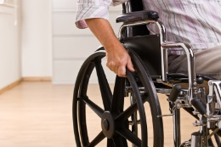

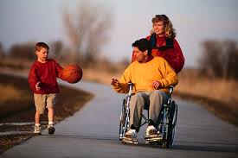

H. Brown
2022

INTRODUCTION

These notes summarise a selection of findings from the 2022 report ‘People with Disability Australia’ published by the Australian Institute of Health and Welfare’.

This report and its accompanying tables, assemble an extensive range of statistical information about the scope and impact of disability in the Australian community, coupled with a thorough account of the trends which this information reveals.

This report includes the findings of national surveys and other data about the circumstances and experiences of people living with disability, including their health, housing, living arrangements, family responsibilities and circumstances, personal wellbeing, assistance, educational participation and outcomes, paid employment, incomes, experiences of violence and discrimination, and others.

This summary presents a brief selection of that information, highlighting differences among people of various degrees of disability, ages, sex or other circumstances, where such distinctions exist.

The full report and tables are available on the internet:
- The report is available here, or at: https://www.aihw.gov.au/reports/disability/people-with-disability-in-australia/

- Its data tables are situated here, or at: https://www.aihw.gov.au/reports/disability/people-with-disability-in-australia/data

Together they form an invaluable resource, providing an insight into contemporary social circumstances affecting people living with disability.

CONTENTS

Prevalence of Disability 1
Access and Mobility 4
Assistance 7
Health and Wellbeing 10
Discrimination and Harassment 12
Violence 14
Education 16
Employment 18
Incomes 19
Household and Family Circumstances 20
Housing 21

PREVALENCE OF DISABILITY

A little over one in six (17.6%) of Australians live with a disability: 5.7% severe or profound disability (needing assistance with self-care, mobility and/or communication) and 12% moderate or mild.
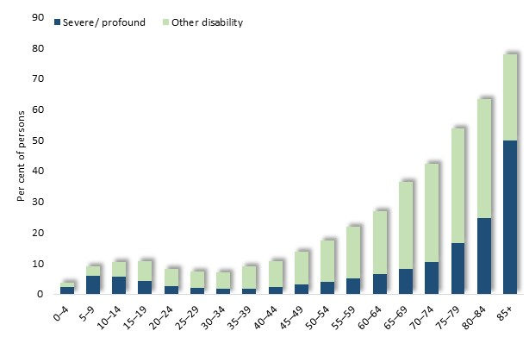
The proportion of people with a disability rises steeply from early childhood, from 3.8% of those aged 0-4 years to over 10% aged 10 to 19 years. In early- and mid-adulthood, the prevalence of disability declines, before commencing a steady rise into old age. By 85 years and more, four-fifths of people have a disability, including half with a severe or profound disability.

Per cent of people who have a disability, by age and disability status, 2018

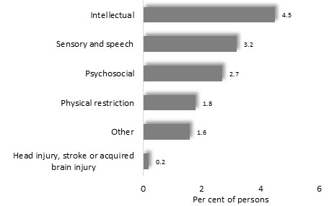
For children aged up to 14 years, intellectual impairment is the most prevalent form of disability.

Prevalence of disability by type: people aged 0 to 14 years: Australia, 2018

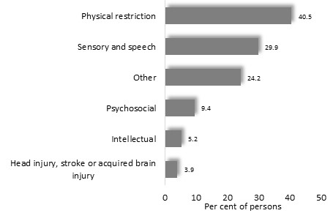
In older age though, physical restriction supplants intellectual disability as the most widespread form.

Prevalence of disability by type: people aged 75 to 84 years: Australia, 2018

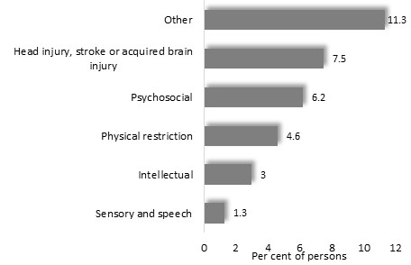

Prevalence of disability by type: Australia, 2018

Further information about patterns of disability shows that among children and young adults, common impacts of disability include learning, social and speech problems, and mental illness.
Per cent of people aged 0 to 24 with a disability, by type: Australia, 2018
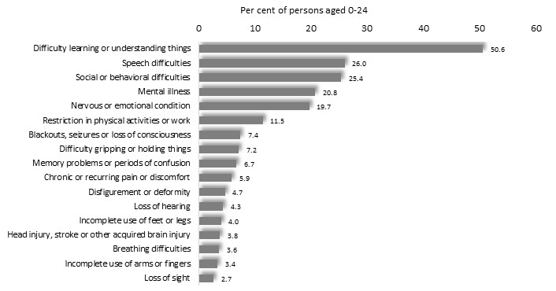

By working age, physical restrictions and chronic pain are among the predominant types of disability
Per cent of people aged 25 to 64 with a disability, by type: Australia, 2018
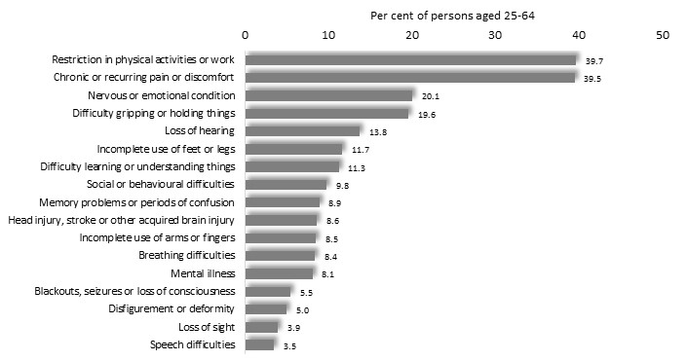

Among older disabled people, physical restrictions, pain and discomfort, impaired co-ordination and hearing loss are prevalent.

Per cent of people aged 65 years or more with a disability, by type: Australia, 2018
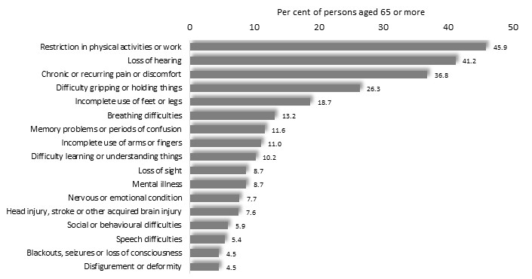

ACCESS AND MOBILITY

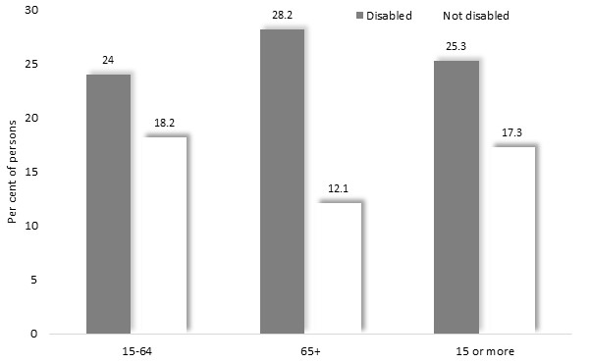
A quarter (25%) of people with disability aged 15 or more, and 17% of people without disability, have difficulties getting to places which are important to them.
Notably, of older people - among whom many disabilities entail a physical impairment - over a quarter experience difficulty getting to places needed – more than twice the proportion of people the same age without disability.

Per cent of people with a disability who cannot, or have difficulty, getting to places needed, by age: Australia, 2019

A related issue is the level of physical access among people with disability, to places of importance to them. Among people with disability and living in households, a third (32.5%) have difficulty accessing buildings or facilities
Specific features of buildings or localities where access difficulties are reported by people with mobility or communication limitations, include the vicinity and approach to buildings, and car parking facilities, making these features of the built environment important considerations in achieving accessible design.

Per cent of people with disability, aged 15 years and over, living in households, who need assistance or have difficulty with communication or mobility, and had access difficulties in the last 12 months, by types of venues and locations where they experienced access difficulty: Australia, 2018
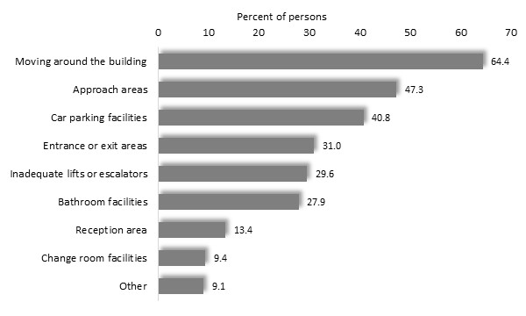

Over a third (37%) of people with severe or profound disabilities, and about one in ten (9.5%) of people with other disabilities, experience difficulty with public transport. A similar proportion are unable to use public transport at all. This means that about two-thirds of those with a severe or profound disability either have difficulty with, or are unable to use, public transport.

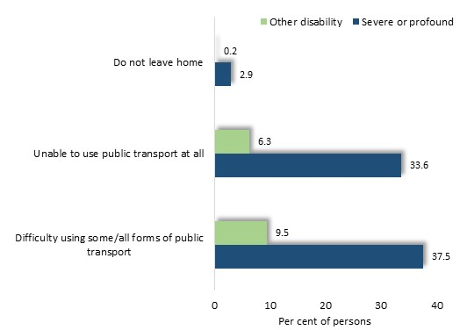
Per cent of people 15 years and over, with disability and living in households, who have difficulty using public transport, by disability status: Australia, 2018

Reasons for such difficulties include steps and other access points, anxiety, getting to steps, discomfort when seated and lack of seating.

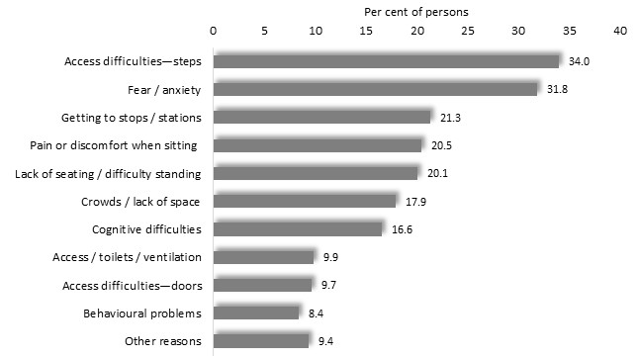

Per cent of people aged 15 to 64 years with disability and living in households, who have difficulty using public transport, by reasons for difficulty using public transport: Australia, 2018

A related issue is avoidance of certain situations, whether for reasons related to physical access, personal apprehension or other circumstances.
Over two-thirds of people with severe or profound disability and aged 15 to 64 years, have avoided situations in the previous 12 months. A lesser number of those with other disabilities report the same experience.
Notably, the proportions of disabled people who avoid situations declines with age.

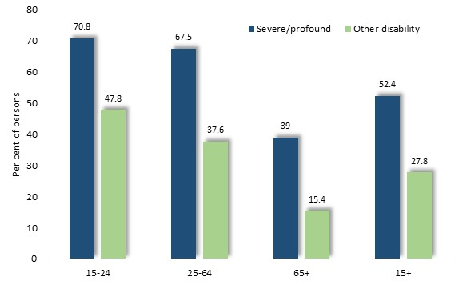

Per cent of people aged 15 years and over, with disability and living in households, who had avoided situations because of disability in the last 12 months, by disability status and age: Australia, 2018

Among situations avoided are social settings, including meeting family and friends, as well as shops, restaurants, cafes and employment-related situations.
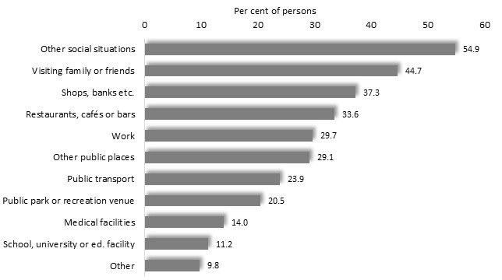

Per cent of people aged 15 to 64 years with disability, living in households, and who avoided situations because of disability in the last 12 months, by types of situations avoided: Australia, 2018

ASSISTANCE

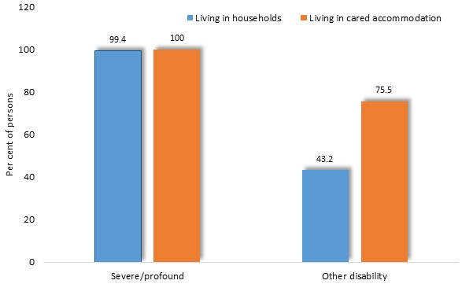
Nearly all people with severe or profound disabilities, regardless of their living arrangements, require assistance with at least one activity. Among others with disability, more of those living in cared accommodation require assistance (75%) than those living in households (43%).

Per cent of people with disability who need assistance with at least one activity, by disability status and living arrangement: Australia, 2018

The proportion of people with a disability and living in households, who needed daily assistance with at least one activity, varies with age, from 71% among 0 to 24 year-olds, to 53% of those aged 25 to 64 years and 63% of older people.

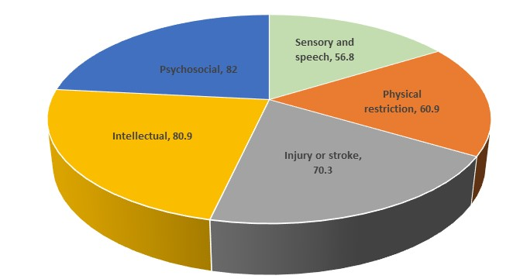
The proportion of people aged 0 to 64 years who require assistance, varies among the major categories of disability, with psychosocial and intellectual assistance the most often required

Per cent of people aged 64 years and under, with a disability and living in households, who need assistance with at least one activity, by type of disability: Australia, 2018

The range of tasks for which assistance is needed, differs with age. For example, assistance with cognitive or emotional tasks is most often needed by younger people - represented in blue in the diagram below. By contrast, assistance with property maintenance is required by 60% of older people who need assistance but just 6% of those aged 15 to 24 years.
Overall, assistance with cognitive or emotional tasks is most often sought by younger people who need assistance, while assistance with health care, transport, household chores and mobility predominate among the needs of older people. (Diagram, below)
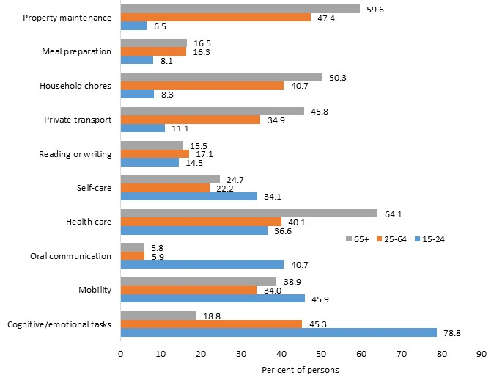

Per cent of people with disability, living in households, who need assistance with at least one activity, by types of activity for which assistance is needed and age: Australia, 2018

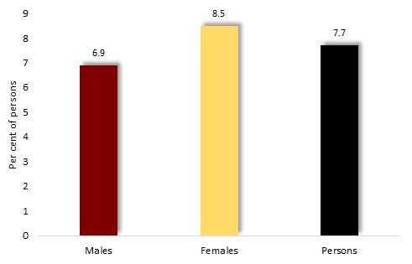

Among disabled people aged 0 to 64 years, 7.7% use mobility aids, with a slightly higher proportion of women than men requiring such assistance.

Per cent of people with disability aged 64 and under, who use mobility aids, by sex: Australia, 2018

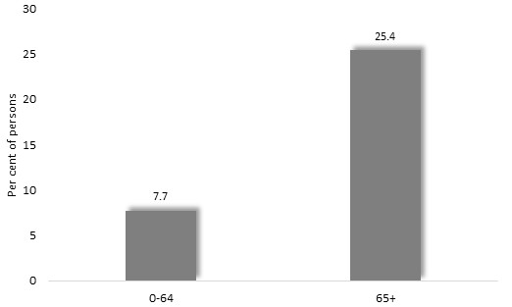
Dependence upon mobility aids differs more widely with age.
Of people aged 65 or more, with disability, a quarter (25.4%) use mobility aids.

Per cent of people with disability, who use mobility aids, by age: Australia, 2018

The most widely use mobility aids include walking frames, used by 7.6% of people with a disability, walking sticks, used by 6.2%, wheelchairs and canes.
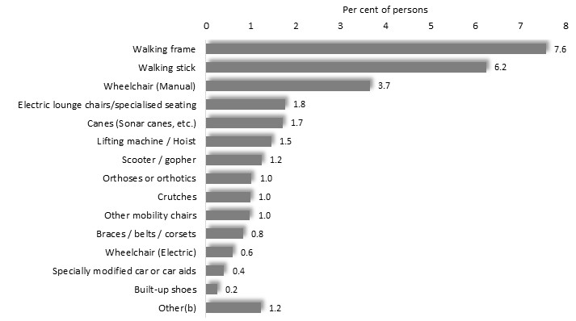
Per cent of people with disability who use mobility aids, by type of aid: Australia, 2018

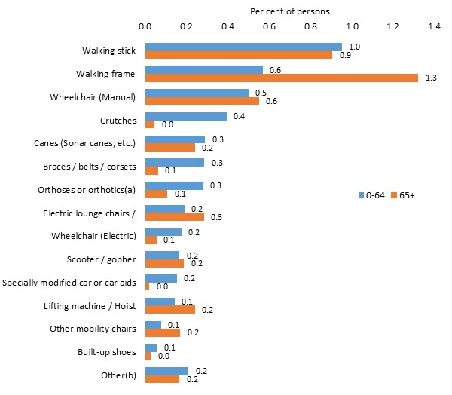
The types of mobility aid used vary with age.
The use of walking frames is more common among people aged 65 years or more, while a higher proportion of younger people with a disability employ mobility aids, such as braces, orthoses or crutches.

Per cent of people with disability who use mobility aids, by type of aid and age: Australia, 2018

HEALTH AND WELLBEING

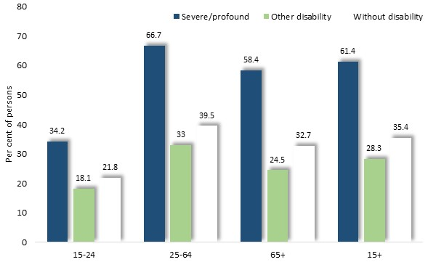
People with severe or profound disability are more likely to rate their health as fair or poor, than others with disability or those without disability. Overall, nearly two-thirds of people with severe or profound disability aged 15 years or more, give such a rating of their overall health.

Per cent of people aged 15 years and over, with disability, living in households who rate their health as fair or poor, by disability status and age group: Australia, 2018

Social isolation is experienced by about one in seven people with disability, and is most prevalent among younger disabled people, with nearly one fifth of those aged 15 to 44 years reporting this experience.
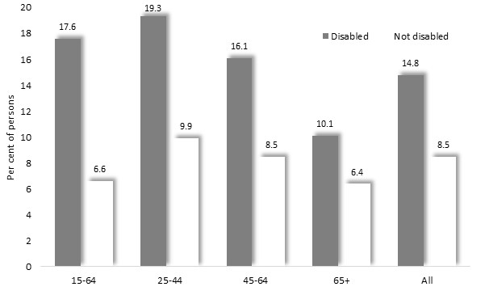
Per cent of people aged 15 years and older, who experience social isolation, by disability status and age: Australia, 2017

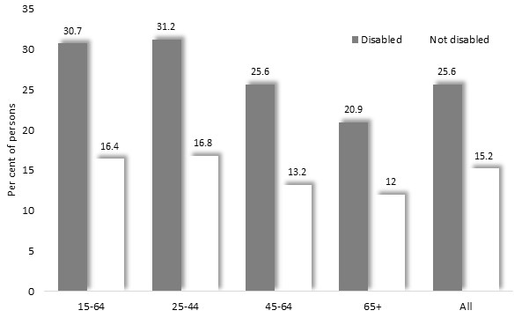

Similarly, a quarter of people with disability experience social loneliness – a condition most prevalent among those aged 15 to 44 years.

People aged 15 years and over who experience loneliness, by disability status and age: Australia, 2017

About one in six (13.7%) adults with a disability experiences 'very high' levels of psychological distress, compared with 8% of people without disability. The proportion of disabled people with such personal distress is greatest among those aged 18 to 64 years.

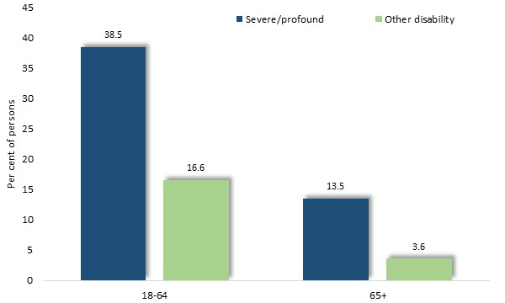
For example, among people with severe or profound disability, the proportion with 'very high' distress declines from 39% of those in the younger age range to 14% of older people.

People aged 18 years and over with disability living in households, with 'very high' distress levels, by disability status and age: Australia, 2018

Nearly 14% of people with a disability are not satisfied with life – over three times the corresponding proportion of 4% among people without disability. The proportion of disabled people who are not satisfied with life is highest among those aged 25 to 44 years - reflecting a trend also seen int he general population, through at lower levels.
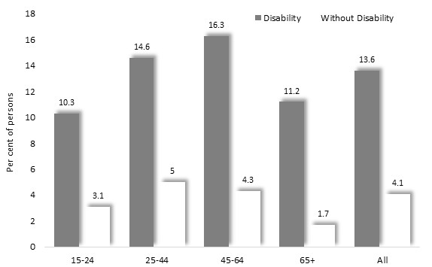

People aged 15 years and over, who are not satisfied with life overall, by disability status and age group: Australia, 2017

DISCRIMINATION AND HARASSMENT

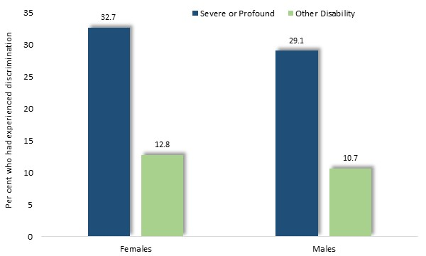
About one in seven (16%) people with disability report that they have experienced discrimination based upon their disability in the previous 12 months. Such incidents are more common among people with a severe or profound disability, with nearly a third having such experiences, compared about one in ten people with other disability.

People aged 15 to 64 years with disability and living in households, who had experienced disability discrimination in the last 12 months: Australia, 2018

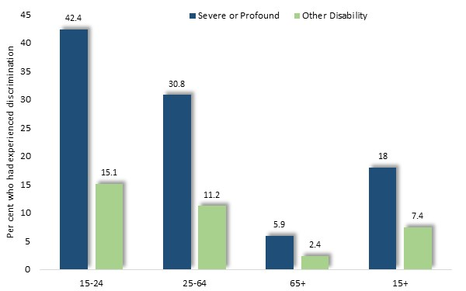
The percentage of people with disability who experience discrimination declines with age, though among all age groups is more common among those with severe or profound disabilities. Among people aged 15 to 24 years and with severe or profound disability, for instance, over two-fifths (42%) report having experienced discrimination in the previous 12 months, compared with 15% of those with other disabilities.

People aged 15 to 64 years, with disability, living in households, who had experienced disability discrimination in the last 12 months: Australia, 2018

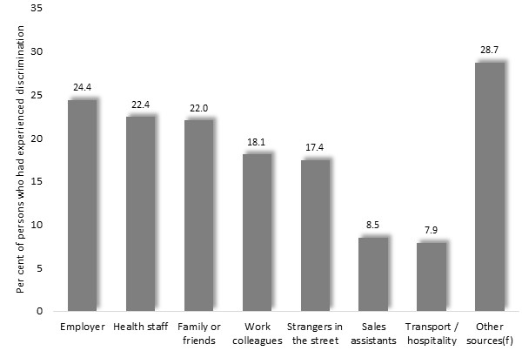

Discrimination arises from a variety of sources, including employers and work colleagues, health staff, family, friends and strangers on the street.

People aged 15 to 64 years, with disability, living in households, who had experienced disability discrimination in the last 12 months, by source of discrimination: Australia, 2018

Sources of discrimination vary with age, with people with disability aged less than 65 years, more likely than others to cite their work environment as a place where they had experienced discrimination.
Indeed, over a third of disabled people aged 15 to 64 years, who had endured discrimination, cited their place of work or study as a source of this experience.

People aged 15 years and over with disability living in households who have experienced disability discrimination in the last 12 months, by source of discrimination and age: Australia, 2018
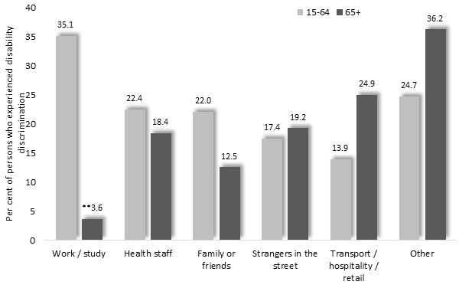

Sexual Harassment
Overall, nearly one in seven people with a disability and aged 18 or more - including one in ten males and one in five females, had experienced sexual harassment in the previous 12 months.
Such experiences are slightly more common among people with disability, than among others.

Per cent of people aged 18 years or more, who have experienced sexual harassment in past 12 months, by disability status: Australia, 2016
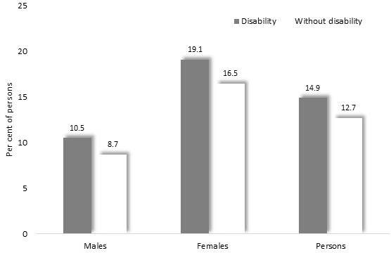

VIOLENCE

People with disability are more likely than those without disability to have experienced violence since the age of 15 years, including sexual, physical or intimate partner violence.
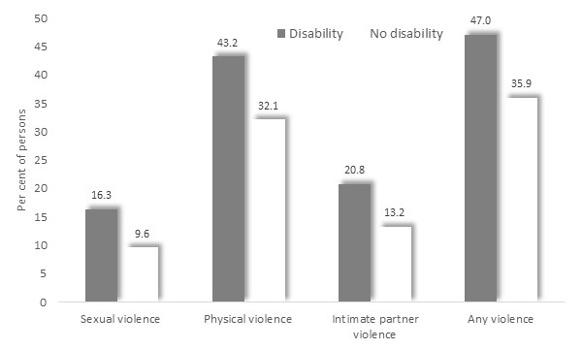
For example, 21% of people with disability have experienced violence from an intimate partner since age 15, compared with 13% of people without a disability.
Similarly, the prevalence of the experience of physical and sexual violence since age 15, is markedly higher among people with disability.

People aged 18 years and over, who had experienced violence since age 15, by type of violence: Australia, 2016

A similar proportion of women and of men with disability have experienced violence since age 15. However, over 25% of women with disabilities have experienced sexual violence – nearly four times the corresponding level of 6.6%, among men.
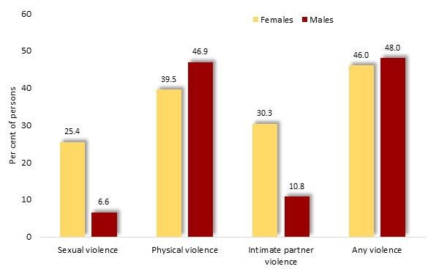
Similarly, 30% of women with disability have endured intimate partner violence, compared with 11% of mem.

People with a disability who had experienced violence since age 15, by type of violence: Australia, 2016

Among people with disability, most of the perpetrators of violence were known to them, with 38% citing a known person - including a partner, acquaintance or neighbour - as the source of violence, and 20% a stranger. (The sum of the percentages in each category of perpetrator exceeds the total proportion who had experienced violence, as some may have experienced violence from more than one category of people)

People aged 18 years and over who had experienced violence after age 15, by relationship to perpetrator and disability status: Australia, 2016
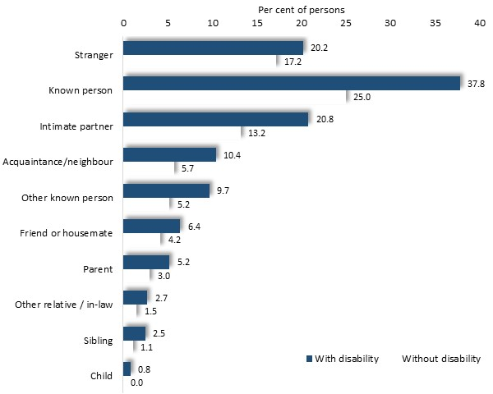

Child Abuse
A substantial proportion of adults with disability report that they had experienced abuse during childhood. Nearly one-quarter (23%) of disabled people aged 18 years or more had been abused before the age of 15, compared with 13% of people without disability.
A further notable trend is that 16% of disabled women had been sexually abused in childhood - about twice the proportion of disabled men, and of women without disability.
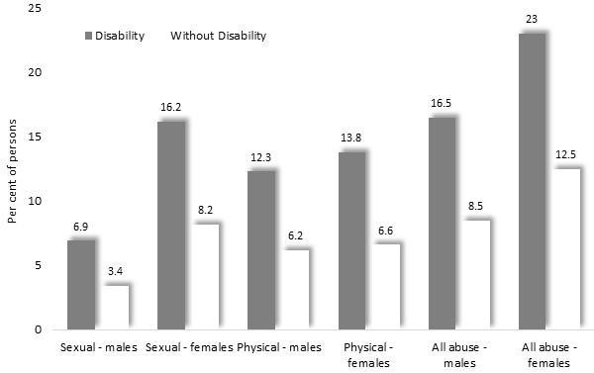

People aged 18 years and over who experienced abuse before age 15, by disability status, sex and type of abuse: Australia, 2016

EDUCATION

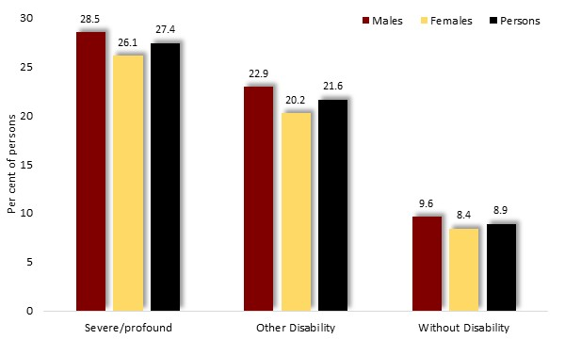
Population surveys reveal substantial educational disadvantage among people with disabilities. Those with severe or profound disabilities are three times as likely to have left school before reaching 16 than people without disability; and other people with disability are twice as likely to share that experience.

People aged 15 to 64 years and living in households, who left school aged 15 or less, by disability status and sex: Australia, 2018

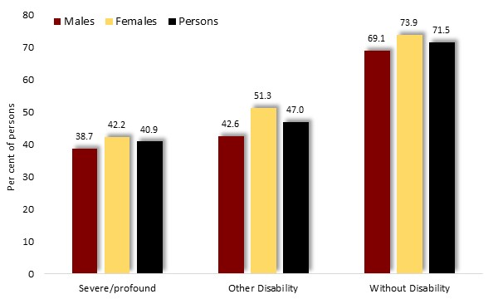
Rates of year 12 completion vary moderately with disability group

People aged 15 to 64 years and living in households, who completed year 12, by whether completed year 12 or equivalent, by disability status and sex: Australia, 2018

The proportion of people with a disability who had competed year 12 differs widely with age though. Among people with profound or severe disability, 67% of those age 15 to 24 completed year 12, compared with 21% of those aged 65 years or more. A similar pattern, though with higher rates of completion, is seen among others with disability.
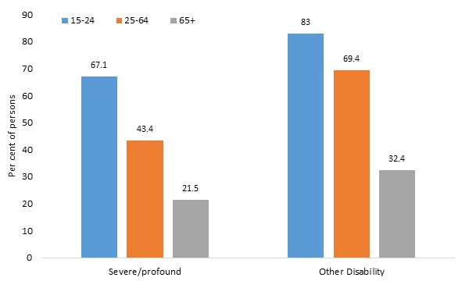

People aged 15 years and over, living in households and not at school, who completed Year 12, by disability status and age: Australia, 2018

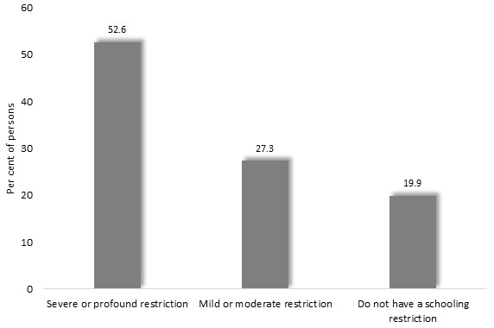
Among school students with a disability, and aged 5 to 18 years, over half experience severe or profound restrictions upon their educational participation, and 27% moderate restrictions.

School students with disability, aged 5 to 18 years and living in households, by schooling restriction: Australia, 2018

Approximately three-quarters of disabled people who experience restrictions report difficulty with school, over half receive special assistance from a school staff member, about a fifth attend special classes, and one in seven is enrolled in a special school.

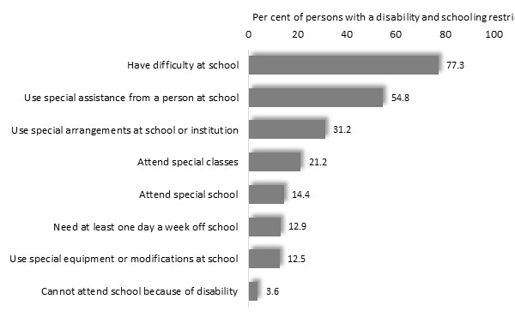
People with disability who have a schooling restriction, aged 5 to 18 years and living in households, by type of schooling restriction: Australia, 2018

A further one in ten (10.4%) disabled people aged 5 to 18 years, do not attend school - similar to the proportion of people without disability who are not attending (10.8%).

EMPLOYMENT

Eighty per cent of people aged 15 to 64 years without disability are in paid employment, compared with 48% of people with disability – including 24% of those with a severe or profound disability and 56% of others with a disability.
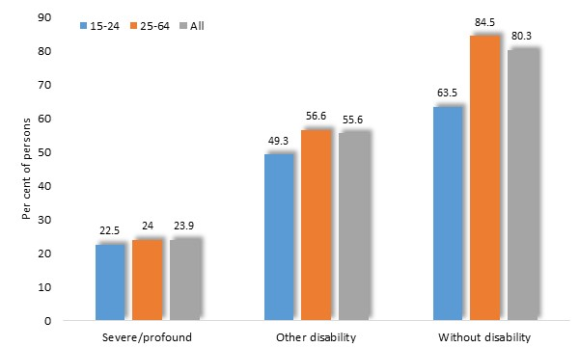

Percent of people aged 15 to 64 years and living in households, who are in employment, by disability status and age group: Australia, 2018

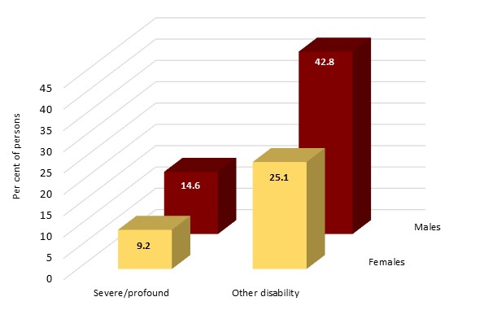
Twenty-eight per cent of people with disability are employed full-time and a 20% part-time. Those with severe or profound disability are a third as likely (11%) to hold full-time paid employment as others with disability (34%).
In a further notable trend, women with disabilities - either severe/profound or others - are less likely to have paid work than males. For example, among people with other disability aged 15 to 64, 25% of females are in full-time paid work, compared with 43% of males.

Per cent of people aged 15 to 64 years and living in households, who are working full-time, by disability status and sex: Australia, 2018

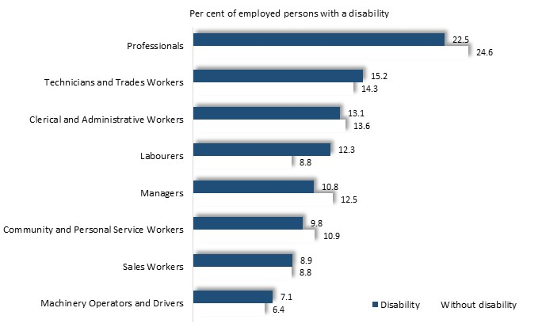
Among employed people, the pattern of occupations among those with and without disability is similar. However, a higher proportion of employed people without disability work in professional and managerial fields, while disabled people are more likely to hold labouring jobs.

Employed people aged 15 to 64 years, living in households, by occupation and disability status: Australia, 2018

INCOMES

The proportion of people who do not have an income differs little between those with disability and those without. Among people aged 15 to 64 years, one in ten of those with and without disability have no income.
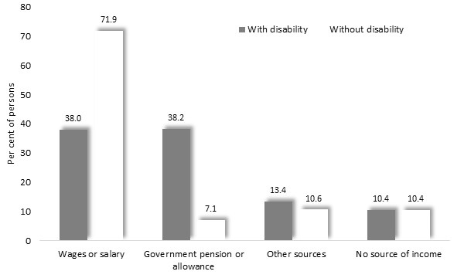
There are however, wide differences in sources of income between people with disability and others. Among disabled people aged 15 to 64 years, 38% receive an income from employment - little over half the corresponding proportion of people without disability. Conversely, at 38%, people with disability are five times more likely to receive a government allowance than those without a disability (7%).

People aged 15 to 64 years, living in households, by main source of income and disability status: Australia, 2018

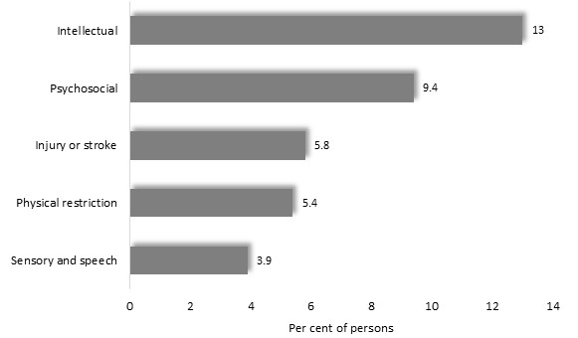
Access to an income differs by type of disability. Among people with a disability and aged 15 years or more, 13% of those with an intellectual impairment have no income, compared with 5% of people with a physical restriction and about 4% with sensory or speech-related disabilities.

Per cent of people with a disability and aged 15 years or more, who have no source of income, by disability group: Australia, 2018
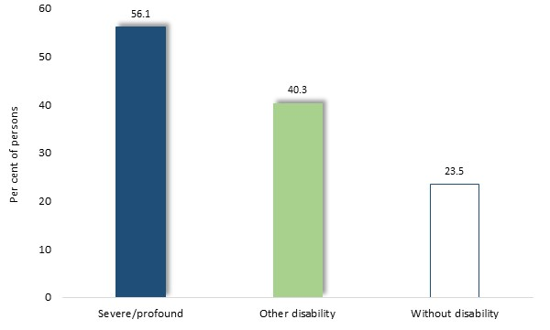
Forty-two per cent of people with a disability and aged 15 to 64 years are unsatisfied with their personal financial situation, including over half of those with a severe or profound disability and two-fifths of people with other disability. By contrast, less than a quarter (23%) of people without disability hold similar concerns.

People aged 15 to 64 years who are not satisfied with their financial situation, by disability status: Australia, 2017

A similar proportion of women (41%) and men (44%) expressed dissatisfaction with their financial situation
HOUSEHOLD AND FAMILY CIRCUMSTANCES

Parenting
Nearly a third (29%) of people aged 15 to 64 years with a disability, have parenting responsibilities to children aged 17 years or less.
Women are more likely than men hold such responsibilities. Among people with disability aged 25-34 for instance, women are nearly twice as likely to have parenting responsibilities.
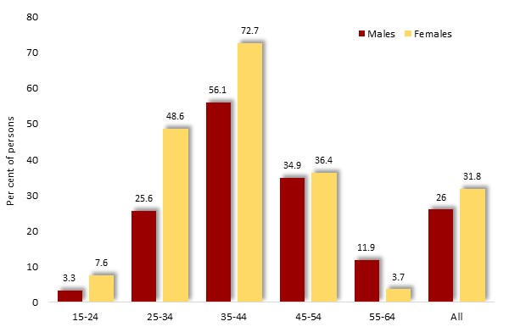

People aged 15 to 64 years with disability, by whether have parenting responsibilities for any children aged 17 years or less, by sex and age: Australia, 2017

Relationship in the Household
People with disabilities and aged 15 years or more, are less likely than those without disability to be a parent of children within their household, and more likely to be lone parents or occupants of lone person households.

Non-dependent people aged 15 to 64 years living in households, by household relationship and disability status: Australia, 2018
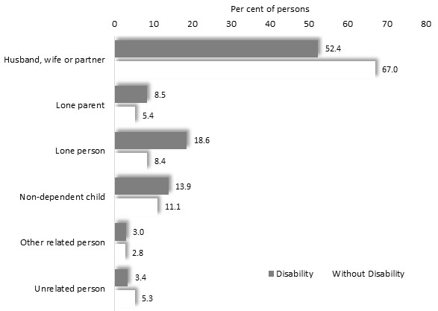

HOUSING

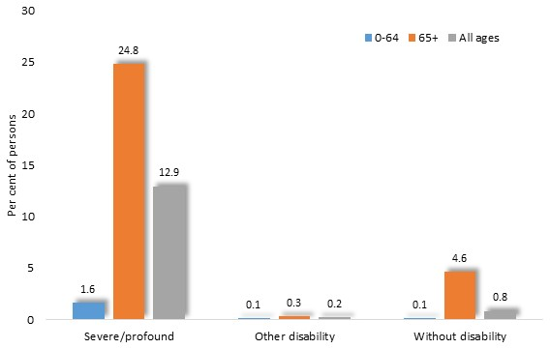
Approximately one in twenty-five (4.3%) people with a disability live in cared accommodation – including 0.6% of those aged 0 to 64 years, and 9% of those aged 65 or more. Among those with severe or profound disability, the proportion in cared accommodation rises from 1.6% of those aged less than 65 years, to 25% of those over 65 years.

People living in cared accommodation, by disability status and age: Australia, 2018

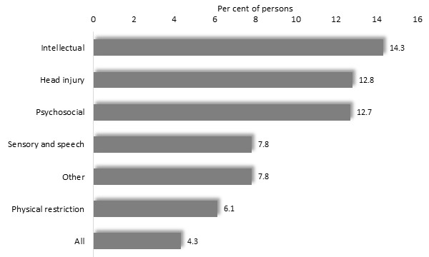
The proportion of people with disability who are living in cared accommodation, varies with their category of disability. More than one in ten people with intellectual, head injury or psychosocial disabilities are in cared accommodation, compared with about 8% with sensory or speech limitations and 6% of those with physical restrictions.

People with disability living in care accommodation, by disability group: Australia, 2018

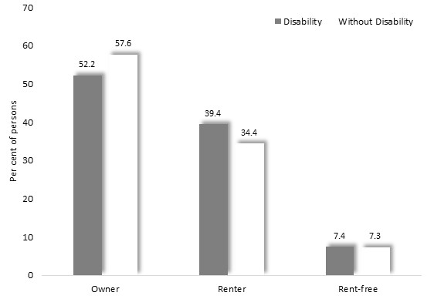
People with disabilities are slightly less likely to own the home in which they live, than others.

People living in households, by tenure type and disability status: Australia, 2018

Among people aged less than 65 years though, rates of home ownership differ more markedly, with 44% of people with severe or profound disability owning their home, compared with 55% of others with disability and 58% of people without disability.

