CONTENTS

1 Nature & limits of social statistics 1
Social information and its uses 1
How people and events are counted 1
Does it actually mean anything? 3
Trust and doubt 4
2 Turning numbers into knowledge 5
Selecting: a goal and the information required 5
Specifying: getting information about specific groups of people 6
Comparing: people across localities, segments of the community & time 9
Clarifying: information so its most important details are revealed 12
3 From nation to neighbourhood:
Using national or regional information to point to local conditions 15
4 Obtaining social information 16
Nature and sources of social information 16
A table of sources of social statistics 16
Sources of reliable social statistics 17
Australian Bureau of Statistics 17
Victorian Local Governance Association 20
Department of Sustainability and Environment 21
Community Indicators Victoria 22
Listening and talking 23
4 Appendix i
I Local and regional statistics 1
II National and state statistics 5
III Statistical guides and directories 9

Knowing Your Community
A guide to understanding and using social statistics

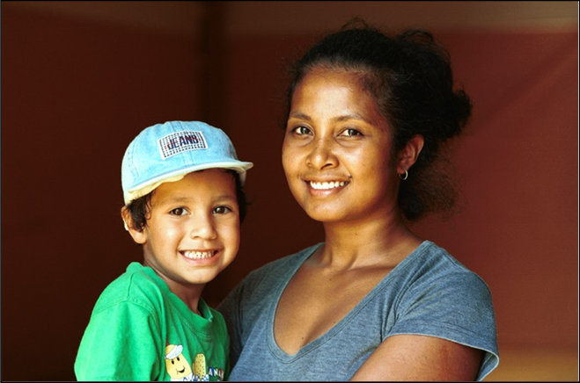
PART ONE: The nature & limits of social statistics

Social information and its uses
“If everybody is thinking alike, then somebody isn't thinking.”
Information about communities can help us understand people and the circumstances in which they live, how conditions are changing, and some of the reasons for those trends. Such information can inform opinions and decisions, provide the means to monitor social conditions, and support advocacy and service or community planning.
Social information is of two main kinds:
Descriptive: Often called ‘anecdotal’, descriptive information describes the circumstances, experiences, perceptions and feelings of individuals or small groups of people. Examples include accounts of migrant settlement; the experience of poverty; and the practise of a particular faith in a community. This information can provide a richly detailed picture of people and their circumstances.
Numerical: Learning about groups of people, such as communities or nations, often requires that people be counted. Such information is therefore expressed in numbers. Examples include the number of settlers, how many families live in poverty, the percentage of people practising a particular religion, and so forth. Numerical information is really about crowds, rather than individuals.

How people and events are counted
Numerical information about people includes:
- counts of all people in the population or community;
- random surveys of a sample of a community;
- workload measures - which only record the level of contact between people and organisations.

Counts of the whole community
Counting every member of a community, or of a particular group, is the surest way to obtain an accurate measure of the number and characteristics of people – even in smaller communities.
The main source of full counts of the community is the national Household and Population Census conducted every five years, most recently in August 2006. Censuses are especially useful. First, since they count all people, the results can tell us about communities of various sizes - from nation to neighbourhood. Secondly, as the Census records a wide range of information about each individual and household – such as age, sex, birthplace, spoken language, housing, education, employment and so on – the relationships between these characteristics can be determined. For instance, one may learn of how incomes vary among people of different birthplaces, or discover the relationship between unemployment and fluency in English.
Aside from the Census, full counts of certain events are maintained by government agencies as a part of their overall functions. Examples include records of all births, deaths, marriages and divorces; of house prices, rent levels and construction; and the settlement of recently-arrived migrants.
Finally, sometimes a smaller group of people in the community may be fully counted - as for instance, in a survey of all members of a town or other small community.

Random Samples of the community
When it is too expensive or arduous to count all members of a community, a sample of people may be chosen instead. Where the selection of people is carried out in such a way that all people in a community have the same likelihood of being chosen, the sample is said to be random. Random samples confer an enormous advantage: if enough people are selected randomly, then the percentage of people of each sex, age or other category will generally be much the same in this sample as for the wider community. In this way, counting a few hundred people can provide a reasonably accurate glimpse of a far larger community.
Among sample studies of this kind are national surveys conducted by the Australian Bureau of Statistics about child care, unpaid work, employment, literacy, family violence, health, disability, retail sales, business confidence, community wellbeing and other issues. Many of these surveys are listed in the appendix.
Random surveys of the population may also be conducted by governments, universities, commercial or political organisations, and others.
However, if only a small number of people are chosen from the community, chance alone may result in a sample of people who do not form a balanced representation of the overall community, making the results unreliable. On the other hand, even if a sizable sample is selected, if too many people decide not to participate, then those who do respond may not represent a true cross-section of the community.

Workload Measures
A third kind of information is a count of people or incidents which come into contact with an agency or service. Instances have been mentioned where agencies record information about all people or events of a particular type, such as records of immigration, births, deaths, marriages and divorces. But if an agency records details of only some of the people or incidents of a particular kind, then the results may inform us of the work done by an agency but provide no dependable suggestion about conditions throughout society. Examples include the records kept by human welfare agencies about people seeking health treatment, assistance with gambling problems and records of child abuse, family violence and crime.

- eg: In 2006/7, 376,000 offences were reported to Victoria Police, including 31,000 assaults. However, the findings of the 2006 national Survey of Crime and Safety reveal that many crimes are not reported, with just one-third of assaults being reported to police. Therefore, records of reported assault do not reflect the true level of such crime throughout the community.

Sometimes it is supposed that the number of people or incidents counted by an agency [such as people with gambling problems, cases of child abuse, and number of crimes] may at least reflect the relative numbers of people or incidents of that kind, in one community compared with another. For instance, a doubling in the number of reported cases of child abuse might seem to indicate that the number of incidents throughout society had doubled also. The same approach is often taken when comparing the number of offences recorded by police across time or between localities.
Perhaps such assumptions are often true; they not necessarily so. For example, an increase in the number of cases of child abuse in one locality, or at a particular time, might reflect a rise in staff levels or other resources rather than any change in the actual level of abuse in the community.

Does it actually mean anything?
"Doubt is the first step to knowledge"
Questioning the meaning of social statistics can help avoid misunderstanding or deception.
There is a variety of reasons why social information may paint an inaccurate, or deceptive, picture.
Information may not be collected or documented accurately; conclusions may be reached on the basis of surveys of a non-random sample of people; people may not provide accurate and consistent replies to questions due to lapses in memory; others may be reluctant to disclose information that may embarrass them; or questions asked may be ambiguous or unclear.
eg: In reply to questions about their own health, some people with chronically poor health rate it as ‘satisfactory’ or ‘good’, because they have become accustomed to their health-related limitations. However, a healthier person who has recently experienced a marked deterioration in health, might rate an equivalent level of health as ‘poor’, since they are unused to their condition and more keenly aware of the limitations their abrupt decline in health has imposed upon them.
Sometimes, the information supplied by people in a survey or interview may be influenced by the context in which they are asked.
eg: One survey of a random sample of the public, inquired: “Would you support genetic modification to make food healthier?”, attracting 40% responses in favour of genetically modified food. Another survey simply asked respondents if they supported “the genetic manipulation of our food”, and recorded just 10% of responses in favour of genetic modification. The wording can influence respondents’ thoughts about an issue, and thereby affect the results.
Opinions and perceptions expressed by people in response to questions may be difficult to interpret in any case. Even among people who express the same view about a topic, the basis for their ideas may differ widely: some may have formed an opinion from their observations of others, others by personal experience, some from reading the news, others entirely without the distraction of facts or personal experience. An awareness of the reason a person holds an opinion, and the importance of the issue to them, is often as important as knowing the opinion itself. Accordingly, some researchers first determine whether the individual is familiar with the issue, next ask their view about a specific question relating to the issue, then inquire as to why, and how strongly, they hold this opinion.
But even if information is accurate and complete, it may be used to reach conclusions that it cannot sustain. The further subject of how social information may be used to reach conclusions about people and their communities, is therefore just as important as the process of acquiring information in the first place.
Trust and doubt
“If you interrogate statistics long enough they'll confess to anything”
Social statistics are often mistrusted, for they may be presented in a simplistic or deceptive fashion. Such apprehensions are well-founded, and largely stem from the fact that such information is about people.
First, social statistics may influence debates and decisions that affect people’s lives. Many people wilfully misinterpret social information to sway public opinion or influence decisions in their favour. Others may select only that information which is most congenial to their objectives, resulting in an incomplete or distorted depiction of events or conditions.
Moreover, when people or social events are counted, individuals are often assigned to categories – for instance, ‘literate’, ‘sole parents’, ‘immigrants’ and so on. Yet such categories inevitably overlook wide differences in the circumstances, experiences and perceptions of the individuals assigned to each category.
These limitations may be largely overcome though, if social statistics are interpreted with a thoughtful consideration of their strengths and weaknesses, and coupled with the findings of interviews or conversations - where an understanding of people and their lives truly begins.
PART TWO: Turning numbers into knowledge
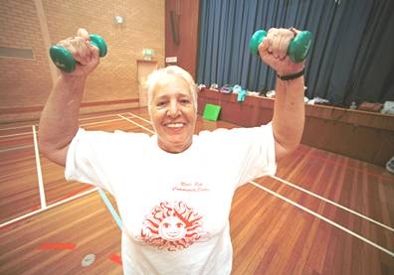
"We are drowning in information and starved for knowledge".

So far, we have considered the nature of social information, how people are counted, what is being counted, and why care should be exercised in interpreting this information. In this section, we turn our attention to the use of social statistics to reach conclusions about people and communities.
It is often easier to get information about social conditions, than to understand what it means. Numbers can be turned into knowledge by:
- Selecting: determining what you want to discover and carefully selecting the information you need
- Specifying: obtaining specific, rather than general, information about people and the circumstances in which they live and work
- Comparing: people in different localities, across time or among segments of a population
- Clarifying: organising information so that it’s most important details are plainly revealed

Selecting: a goal and the information required
"To the one who knows not which harbour to head for, no wind is fair"
Among the most important steps in obtaining information about a community or group of people is to reach an understanding of what information is needed. Without a clear goal or question in mind, it may be difficult to know where and what information to look for, or how to use any information that comes to hand.
An understanding of which issue is being investigated is also important. If research is to be conducted into ‘ill-health’, ‘wellbeing’, ‘disadvantage’, ‘disability’, ‘homelessness’, or a particular ‘ethnicity’, it is well to commence with at least a broad understanding of what these terms are intended to mean.
Similarly, consideration may be given to the community or segment of the population being investigated. For many individuals, the size, geographic scope and nature of their ‘community’ may depend on their interests, lifestyles, mobility, employment and other circumstances. Some people are related to many communities, which may change over time, as interests, activities and circumstances evolve. Many of these communities are not defined by geographic boundaries, but by common characteristics, interests and association of groups of people across a wide area. The advent of the internet, for example, has extended the breadth of some communities across the world.
Likewise, if one were investigating people encompassed by a service, project or market [such as a hospital, community development project, or labour market catchment area] one may need to consider the approximate scope of the geographic area for which it holds relevance. For example, employment opportunities for people in a city, the catchment areas for hospitals, and retail markets, may extend across wide regions.
Specifying: getting information about specific groups of people
The Fog of Generality
Social statistics that describe a community with a single number may inform us about an overall condition or characteristics of the community. Examples include the average income, an unemployment rate, the number of deaths, the proportion of people born overseas, or average educational level. While such information draws attention to general circumstances within a community, though it often provides indication of how conditions may differ among various segments of the community.
Here are some examples, concerned with English fluency and literacy:
- 20% of people in Australia have very limited English literacy [termed ‘Level One Literacy’]
- 16% of people in Australia speak languages other than English
- 2% of people in Australia have limited fluency in the use of spoken English

This information raises more questions than it answers. Who are the people with limited literacy? Which languages are spoken in the community? Who might benefit from English language classes? To which segments of the community would you communicate in languages other than English? And which languages would you choose?
To obtain this more specific information, one may divide the population into specific categories such as gender, age or birthplace, and then look for any differences in social conditions among these segments of the community.
eg: The 2001 Census recorded an unemployment rate of 11% in one municipality - compared with 7% across metropolitan Melbourne. To advocate for better job-training services, one might investigate which segments of the community were most likely to be unemployed. The table below helps to answer these questions with a selection of unemployment rates among people of various birthplaces in a municipality. As these figures show, unemployment rates ranged from 58% among residents from Somalia, to less than 10% among those from India, Sri Lanka, the Philippines and Australia. A chart, on the right, illustrates these differences.

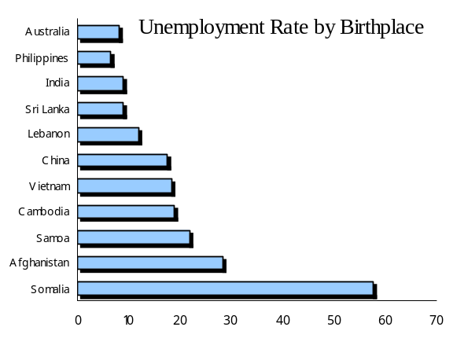
 | 15-64
Somalia | 58
Afghanistan | 28
Samoa | 22
Cambodia | 19
Vietnam | 18
China | 18
Lebanon | 12
Sri Lanka | 9
India | 9
Philippines | 7
Australia | 8

Similarly, levels of home ownership vary widely. Thirty-three per cent of people in Greater Dandenong own their own home – a figure which ranges from 2% among young Sudanese adults, to 98% of older Italian-born residents
- eg: The internet is an efficient way to provide information. But who uses the internet? In 2001, about one third [29%] of people in one municipality used the internet at least once a week. By considering people of various ages, birthplaces and educational levels, one may identify those groups of people in the community who use the internet, and those who do not. The proportion of residents who used the internet ranged from over two-thirds of Sri Lankan and Australian teenagers, to less than 1% of older people from Greece and Turkey. When the education level of older people is considered, the proportions who use the internet ranged from 14% of people with year 12 schooling, to 3% of those without year 11.
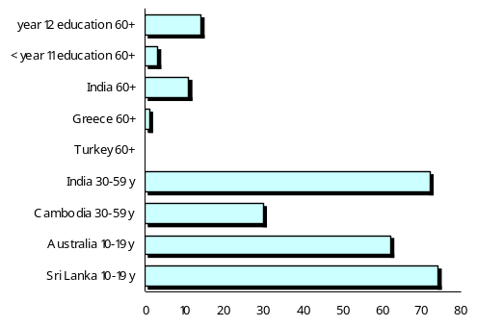
So efforts to communicate though the internet would need to consider alternative approaches for older people, particularly those from non-English-speaking countries or with limited formal education.
- eg: A 1996 national door-to-door survey of literacy found that approximately 20% of people in Australia had the lowest level of literacy. But who would benefit from a basic English course?
Low literacy rates ranged from high levels of 83% among people who learned English after the age of 20, to 64% among settlers who arrived in Australia from non-English-speaking countries, 35% of those with incomplete secondary education, and 25% of people in labouring occupations.
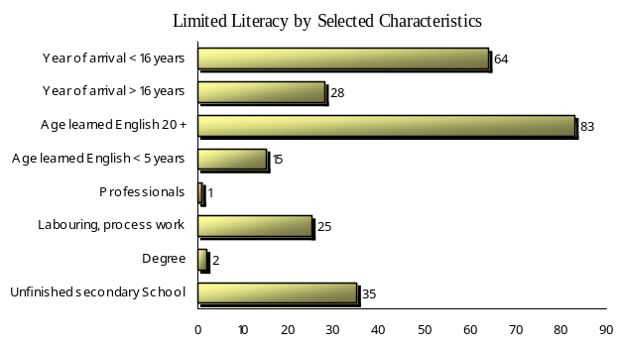
Such information helps to identify those segments of the community which are affected by specific circumstances, and to which assistance should be directed.
Focusing upon a particular group within the community
To investigate conditions among a particular segment of the population – such as settlers, young people, those who are unemployed etc. – it is useful to select information which relates specifically to that group.
- eg: For example, to monitor current educational outcomes, one may measure outcomes for 20-24 year-olds - who would have recently completed school - rather than for the whole community, including older people who may have left school decades ago. In addition, one may determine how such outcomes differed among young people from various birthplaces, localities or genders in 2006 (below).
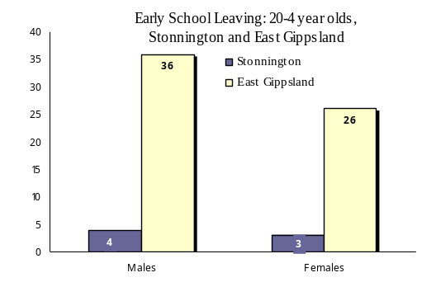

- eg: How many young people have dropped out of contact with the institutions such as work, training and school? While one could measure unemployment among young people, this would count some who were without work but enrolled in education; and counting young people who are not in education would include many who have paid work. One approach would be to count those young people who were neither at school nor in paid work.
Here are the percentages of 20 to 24 year-olds in the City of Boroondara and Baw Baw Shire, who were not in paid work or education at the time of the Census.

Per cent of 20-4 year-olds not in Paid Work or Enrolled in Education
 | Males | Females | Persons
Baw Baw | 22 | 34 | 28
Boroondara | 6 | 4 | 5

In both of these examples the resulting information tells us specifically about contemporary educational and employment outcomes for young people. Such information might be used for advocacy, funding submissions or service planning for employment or educational programs.
The Example of Indicators
An indicator is usually a small piece of information about people or a community, which supplies a suggestion about wider events.
- eg: One indicator of employment and education of young people, may be the percentage of young people who are neither in paid work nor enrolled in education
- eg: An indicator of the burden of gambling losses upon a community may be the amount of money lost to gambling in a community, divided by its adult population.
Indicators are often used to compare conditions between localities and segments of the community, or trace changes over time. Indicators, and any other information used to draw such comparisons, should be:
Valid: measuring what they purport to measure, as well as being relevant and meaningful
Consistent: calculated in the same way from one place, segment of the community, or time, to another.
Sensitive: enough to promptly reveal differences across localities, segments of the community, or time.
Stable: so that chance fluctuations will not overshadow real, underlying changes.
Regular: to enable one to trace changes in conditions across time.
Available: already in existence, or attainable at a cost which is justified by its benefits.
Yet even where indicators possesses all of these attributes they generally only point in the direction of an issue. As we have already observed, if we are to discover how conditions may vary among different groups of people in the community, more specific information may be required.
Comparing - people between across localities, segments of a community or time
The Importance of Definitions: ‘comparing apples with apples’
Often information is compared between one place, segment of the community or time, and another.
To make such comparisons, it is important to ensure that we are comparing the same thing. That makes definitions of the categories of people or events, important. Definitions tell us exactly who, or what, is being counted. For example, issues such as homelessness, poverty, problem gamblers, violence, unemployment, low income, limited English fluency and others, may each have a variety of meanings.
Homelessness | People with no shelter at all.......................... or | also those in refuges, cheap hotels, boarding houses and other temporary accommodation
Poverty | Income below a particular level.....................or | A level of household income which, after meeting the cost of any rent, is insufficient to sustain a basic standard of living for a household of that size and composition
‘Problem gamblers’ | Those whose losses lead to a range of specific and enduring problems [Often estimated from surveys at about 1-4% of the population.] ……...or | Also those who persistently loose more than they can comfortably afford [some estimates put 10% of adults in this category]
Unemployed | People willing and able to work, but employed less than 1 hour per week [4.4% in 2007] …...or | Also those working part-time but who would prefer full-time jobs [5% in 2007]
Violence | Physical or sexual assault…………………. or | Actual assault, as well as attempts or threats of physical or sexual assault
Income | Income before tax……………….or | Total after tax household income, plus the financial value of discounted health, transport, utilities and other services for welfare beneficiaries
Depression | Any prolonged sadness or depression | Prolonged depression which is out of proportion to any external cause or circumstances

Since definitions may vary widely, social conditions must be defined and counted in a consistent way to permit comparisons among different communities, between segments of a community, or across time.
For example:
- Unemployment measured by the Australian Bureau of Statistics Labour Force Survey may not be compared with number of people in receipt of unemployment benefits, since the method by which unemployed people are defined and counted by each of these sources is totally different.
- One may not compare the percentage of people who indicate that they have gambling problems in a survey, with the far fewer people who seek professional assistance from Gamblers Help, for such difficulties.
Fortunately though, when a particular organisation such as the census or a government department, generates a particular kind of information, it is usually measured the same way across communities and over time.
Comparing Groups of People of Similar Age and other Characteristics
Sometimes two groups of people are compared to determine whether differences between the groups are associated with variation in some other characteristic or circumstance. For example, one may investigate:
- How income levels vary among people of different birthplaces
- The range of unemployment rates across a selection of localities
- How the prevalence of smoking differs between employed and unemployed people
However, the conditions being measured – in these examples, incomes, unemployment and smoking – also may vary with age. So when groups of people are compared, it is often useful to choose people of equivalent age.
- eg: In 2006, the Census recorded the median weekly individual income [after tax] in Greater Dandenong at $342 - compared with $481 across metropolitan Melbourne. Generally, such incomes rise with age, and then fall in later life when pensions replace paid employment as the main source of income. As a result, if we were to compare an older group of people such as Italian-born residents, with a younger group such as Australian residents, then we would observe a difference in incomes, simply because of the age difference. Instead, to determine how incomes vary with birthplace, one may consider the incomes of people of the same age span. The table below shows median weekly incomes for 35-44 year-olds from a selection of birthplaces in metropolitan Melbourne, 2006. It shows that the income for Indian-born people of that age range was three times the level for Afghan residents.

Median Weekly Individual Income,
by Selected Birthplaces: Metropolitan Melbourne, 2006
India | $761
Australia | $751
All birthplaces | $700
Philippines | $651
Italy | $616
Serbia | $586
Macedonia | $584
Bosnia | $490
Cambodia | $448
China | $440
Viet Nam | $424
Turkey | $394
Sudan | $267
Afghanistan | $257

Comparing Communities or Groups with Different Age Profiles
Conditions such as the prevalence of disease or disability, the rate of mortality, level of incomes, and the prevalence of home ownership vary widely with age. To compare localities or groups within a community, which may have different age profiles, age-standardized rates or levels may be calculated.
There are three steps to this procedure.
First, for each age group in the community being investigated, the proportion of people within a particular category, is determined. [in the example below: the proportion of people with a disability]. These are called ‘age-specific’ rates.
Second, each of these fractions is multiplied by the number of people within the corresponding age group, within a reference population [such as the population of Victoria].
Third, for each age group, these numbers are added, divided by the population of the reference group and multiplied by 100. This tells us how many people in that reference population would reside in that category [in our illustration, disabled] if the rates of disability for each age group were the same as in the community under investigation. These three steps are illustrated in the table below.
1. Percentages of people with a disability in Port Phillip and Yarriambiak, in each age range, are determined.
2. These percentages are multiplied by the Victorian population of the corresponding age group.
3. The resulting figures are added and divided by the total Victorian population, to give the ‘age-adjusted’ percentage of people in these two localities that have a disability.
Notice that the age-adjusted rate for Port Phillip [a relatively youthful community] is higher than the raw rate, while for Yarriambiak [an older community] the age-adjusted rate is lower than the original.
 | ❶ Percent residents with a disability |  |  |  | ❷ Victorian residents with a disability – based on Port Phillip & Yarriambiak rates
 | Port Phillip | Yarriambiak | Victoria Population |  | Port Phillip | Yarriambiak
0-4 years | 0.5 | 0.9 | 305,939 |  | 1,597 | 2,740
5-14 years | 1.5 | 1.9 | 644,450 |  | 9,526 | 12,196
15-19 years | 1.5 | 1.4 | 335,179 |  | 5,115 | 4,581
20-24 years | 0.5 | 5.8 | 338,714 |  | 1,797 | 19,676
25-34 years | 0.7 | 5.6 | 677,882 |  | 4,491 | 37,805
35-44 years | 1.4 | 5.5 | 741,349 |  | 10,397 | 40,543
45-54 years | 2.8 | 3.8 | 679,517 |  | 19,088 | 25,619
55-64 years | 4.2 | 7.1 | 534,487 |  | 22,656 | 38,016
65-74 years | 10.2 | 7.5 | 345,527 |  | 35,146 | 25,925
75-84 years | 26.7 | 19.3 | 245,506 |  | 65,612 | 47,271
85+ years | 48.8 | 58.2 | 83,873 |  | 40,950 | 48,854
Total | 3.5 | 7.4 | 4,932,423 |  | 216,375 | 303,225
 | Age Adjusted Rates of Disability: |  |  | 4.4 |  | 6.1 ❸

Comparing Numbers, Percentages and Rates: Information in corresponding categories may be compared as numbers or percentages. The choice between these options depends on the nature and purpose of the comparison.
Raw numbers are most useful if the overall number of people, or of a particular category of people, is what counts most.
eg: A project might be planned to address unemployment in a region with three towns, with 400 unemployed in one town, 200 in another, and in the third town 100. On the basis of this information, the first town would appear to be more suitable for a program, as most unemployed people reside there.
Percentages may prove more useful where one is interested, not simply in the number people in a particular category, but in its size relative to the community in which they reside. Percentages, any kind of rate – where the number of people or incidents is divided by the population or a relevant segment of the population - allow one to compare the characteristics of localities, even where the population of these communities differ.
For example, in 2005/6 twice number of offences was recorded in Greater Geelong, as in Maribyrnong. Yet the rate of offences in Geelong was half that of Maribyrnong.
Greater Geelong Maribyrnong
Number of recorded offences: 14,011 7,809
Rate of offences: [per 100,000 population] 6,939 12,599

Clarifying: information so its most important details are revealed
Most social statistics are presented in tables. A few simple steps can help to simplify their presentation and make these tables easier to read and understand. Among the procedures are:
- removal of ‘not stated’ and other insubstantial categories
- adding categories together to create broader, simpler categories
- use of percentages to show more plainly how people are distributed among various categories.
Two examples illustrate these steps.

Housing tenure
❶ The table on the left shows the number of people in each of a range of categories of housing ownership in Brimbank 2006 | ❷ But if we wanted to know how many people owned, were buying, or renting their home, we could remove the 'not stated' and ‘Total Rented’ rows | ❸ Then, we could combine the categories into three groups: fully-owned, purchasing & rented. Finally, we may add a column of percentages

Housing Tenure | Number |  | Housing Tenure | Number |  | Housing Tenure | No. | %
Fully owned | 22,786 |  | Fully owned | 22,786 |  | Owned | 22,786 | 42
Being purchased(b) | 16,583 |  | Being purchased | 16,583 |  | Being purchased | 16,583 | 30
Rented: |  |  | Real estate agent | 10,156 |  | Rented | 14,765 | 27
Real estate agent | 10,156 |  | State housing authority | 574 |  | Other | 323 | 1
State housing authority | 574 |  | Person not in same household | 3,093 |  | Total | 54,457 | 100
Person not in same household | 3,093 |  | Housing co-op./community gp | 362
Housing co-op./comm. gp | 362 |  | Other landlord type | 193
Other landlord type | 193 |  | Landlord type not stated | 387
Landlord type not stated | 387 |  | Other tenure type(e) | 323
Total Rented | 14,765 |  | Total | 54,457
Other tenure type(e) | 323
Tenure type not stated | 1,320
Total | 55,777

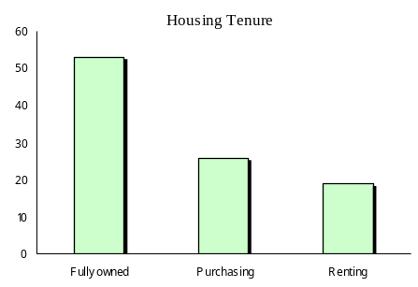
❹ And the results may be depicted in a simple chart
Birthplaces:

❶ The table below lists birthplaces of residents of Maribyrnong from the 2006 Census. |  | ❷ If we only need to know how many people were born in Australia, English-speaking countries & non-English-speaking countries, we could remove the ‘not stated’ and ‘overseas visitors’ categories, then combine the remaining birthplaces to present 3 categories in a table or chart.

 | Persons |  |  | Number | Per cent
Australia | 33,060 |  | Australia | 33,060 | 57
China | 1,653 |  | a/ English-speaking countries | 2,966 | 5
Croatia | 450 |  | b/ non-English-speaking countries | 21,530 | 38
Greece | 1,073 |  | c/ Total - birthplaces stated | 57,556 | 100
India | 1,616 |  | 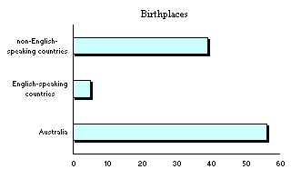
Italy | 1,239
  ❸
Macedonia | 590
New Zealand | 897
Philippines | 694
Poland | 309
Thailand | 132
United Kingdom | 1,596
Vietnam | 6,131
Born elsewhere | 8,116
Not stated | 5,584
Total | 63,140

Clear Visual Presentation: Just as tables of numerical information may be presented in a way that makes it easier to read and interpret, charts and other diagrams can be used to communicate in a straightforward way. As a detailed discussion of this topic falls beyond the scope of these notes, only a few general suggestions are offered here.
Information about several discreet categories is best presented in a bar chart. Plain and clear presentation makes the task of interpreting such information easier.

So consider a simple chart like this… …rather than a complicated & cluttered presentation
Birth Rates: Brimbank & Boroondara, 2005 Birth Rates: Brimbank, Boroondara,
Nillumbik and Murrindindi, 2005
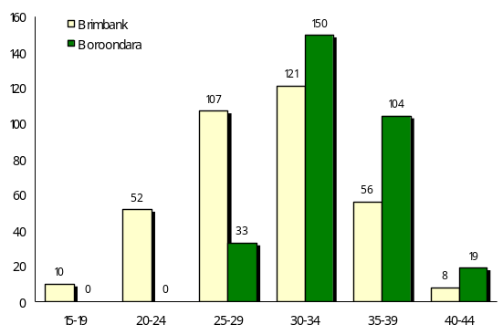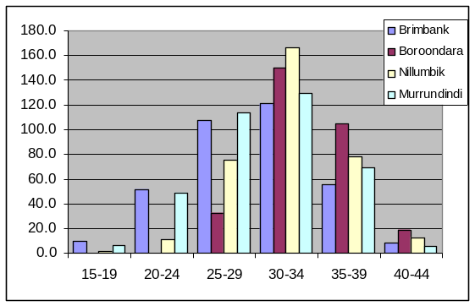

To show how conditions have changed over a period of time, a line graph may be most suitable.
A simple chart may be easier to understand… …than a presentation of all the information at once
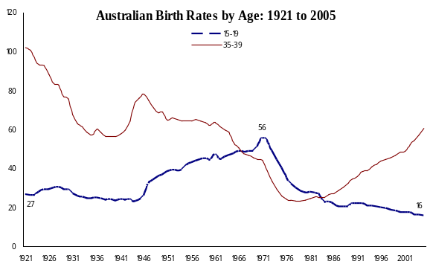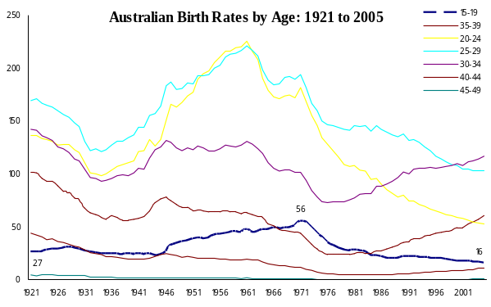

Detailed numbers, including the relationship between two or more characteristics, is best set out in a table.
A simple table may be more clear… …than a detailed chart
Unemployment Rate
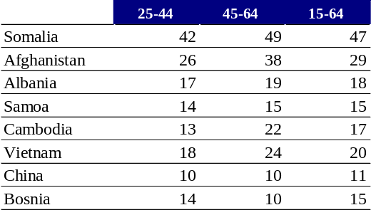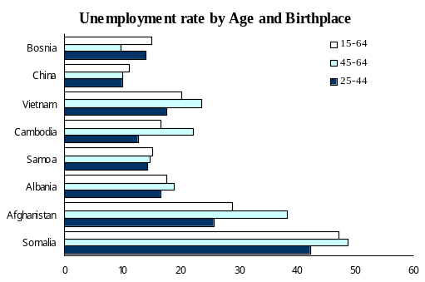

The ‘typical’ person or community: A further way to simplify social statistics is to determine the ‘typical’ or average values. Three measures are the most common category, median and mean.
* Most common category, or ‘mode’, is used when people are being counted and placed in categories that cannot be put into any particular order.
For example, in a community of 1,200 Australian born residents, 250 from Italy, and 2,000 from Spain, the most common category would be Spain, as there are more residents from this country than any other.
Median is the number which falls in the middle, when people are placed in order. For example, if the height of five people was measured, and results were 151 cm, 167, 171, 182, and 196 cm, then the 171 cm would be the median height – the measurement which falls right in the middle. Notice if the maximum height was higher than 196, or the lowest measure was less than 151, it would not affect the median.
Average is calculated as the sum of the measurements divided by the number of measurements.
eg: with the measurements of height in the example above, the average would be calculated as:
(151+167+171+182+196)/5 = 173. Here, a very high or low value will significantly affect the result.
The Hazards of Over-simplification: The more widely circumstances vary, the less ‘typical’ the mode, median or mean becomes.
In the Shire of Wimmera in 2006, the most common category in 2006 was ‘Couples with no children’. However, while this category accounted for more families than any other (49%), it still represented a minority of all families.

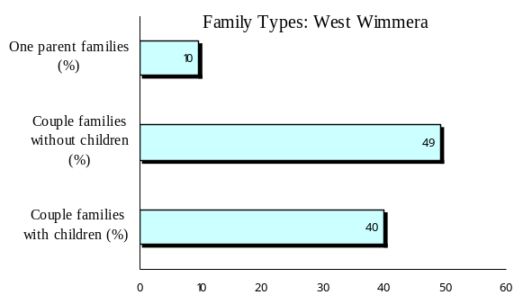

Similarly, if in one street, five houses sold: four of them for about $300,000 and one for $2.3 million, the average price of these houses would be $700,000 – by no means typical of house prices in that street.
In one community:
- The largest single ten-year age group is 20-29 year-olds, who account for 15% of the population
- The largest religious denomination is Catholic, which accounts for 30% of residents
- The main family type is couples with children, which account for 35% of households
But in a profile of the community featured in a local newspaper, it was noted that the typical person in this locality was aged 20-29, a follower of the Catholic faith, and a member of a couple family with children.
In reality, residents who were of this age, faith and family type, accounted for just 2% of all residents!
THREE: From nation to neighbourhood:

using national or regional information to point to local conditions
A further way to use social statistics to obtain a glimpse of local conditions is by
using regional, state-wide or national information to reach conclusions about a particular community.
❶ Assuming conditions in a community match state-wide or national conditions.
First, one might suppose that conditions within a particular locality are the same as those across the nation or state. Such an assumption is generally better than a guess and may be fairly accurate in some instances, such as mortality among people of each age.
However, although the findings of a national or state-wide survey may give a guide to possible conditions within a locality, it is by no means certain that the social characteristics of people in a particular community largely match those of the state or nation.
eg: Median household incomes recorded in the 2006 Census averaged $1,022 per week across Victoria. However, as such income levels ranged from $587 in Braybrook to $2,182 in Kooyong, any estimate of income levels in one particular locality, based on the state-wide average, would be hazardous.
eg: In 2006, 24% of people in Victoria were born overseas. This percentage varied from 4% in Buloke, to 56% in Greater Dandenong though, making it impossible to guess the percentage of overseas-born residents in a community, on the basis of Victorian figures alone.
Eg: Annual losses to electronic gambling machines ['pokies'] averaged $638 per 1,000 adults in Victoria in 2005/6, and range from $151 in Boroondara, to $1,151 in Maribyrnong. The rate of gambling losses in one particular locality therefore, may not be confidently inferred from the state-wide average.
Such variation in local conditions sets limits upon the value of national, state-wide or regional information about some issues as a means for estimating local conditions – at least, in relation to some issues.
❷ Adjusting regional, state-wide or national information to estimate overall local conditions.
Where the percentage of people in a particular category at a national level (eg: people born in a particular country) is linked in a fixed way to a category of the population which is known at a local level (like age), it may be possible to use national or state-wide information to reach conclusions about local conditions.
eg: The 2005 National Health Survey determined the percentage of Australians of each age group who smoke. These percentages can be multiplied by the number of people in each age group in a particular community to estimate the total number of smokers. For instance, if there were 9,000 young people in a town, and if we suppose that 30% smoke - as they do across Australia - then we would expect about 30/100 X 9,000 or 2,700 young smokers in the town.
 | Per cent who smoke [national survey] | X | Population of the town | = | Estimated number of smokers
18-24 | 30 |  | 9,000 |  | 2,700
25-34 | 30 |  | 1,000 |  | 300
35-44 | 29 |  | 10,500 |  | 3,045
45-54 | 24 |  | 8,400 |  | 2,016
55-64 | 17 |  | 7,000 |  | 1,190
65-74 | 11 |  | 5,500 |  | 605
75+ | 4.6 |  | 2,500 |  | 115
Total | 23 |  | 43,900 |  | 10,097
According to this estimate, nearly 10,100 people, or 23% of the adults in the town, smoke.

Often though, it is simply not possible to use national or state-wide information to reach sound conclusions about conditions within a suburb, municipality, town or other locality.


PART FOUR: Obtaining social information

Nature and types of social information
Most reliable social statistics arise from research about society, conducted as censuses or surveys. The broad categories of social information were distinguished earlier may be worth repeating here.
Full Counts: Record information about (nearly) every relevant person or incident, providing a view of conditions within municipalities, suburbs and towns.
Aside from the Census, a range of government agencies provide full counts of people or events, including:
- house prices, rental levels, construction, public hosing stock and residential land development;
- births, deaths, road accidents and immunization;
- business numbers, employment levels & unemployment rates;
- gambling losses;
- education enrolment.
Sample Surveys: National or state-wide surveys of a random sample of people reveal probable conditions across the nation or a state. However, there are often too few people surveyed to tell what is going on in a smaller locality.
‘Workload Indicators’: The kind of information collected by agencies that tells us only about the people or incidents which come to the attention of that agency.
The sources of social information which are discussed in this section are largely those based on full counts of people or events, and those which are derived from random surveys.

A Table of Sources of Social Statistics
Many of the available sources of social statistics are set out in two tables in the appendix to this document
1 Quality local and regional information
The first presents a selection of sources of social statistics that are of a reasonable quality and relevant to social research. Emphasis has been placed upon sources of information about local conditions – at a suburb, town or municipal level - though important regional or state-wide information is also included.
2 State-wide and national information
A second table sets out a range of national or state-wide collections of information about social conditions, mostly published by the Australian Bureau of Statistics. While this information is not duplicated at a local level, it affords a useful view of broader social conditions.
Aside from these two tables featured in the appendix, several websites which provide convenient access to a range of this social information are described in the following pages.
Major Sources of Social Statistics: I

Summary of population, social, health, housing, cultural diversity, educational and other conditions, within all Victorian municipalities:

www.socialstatsitics.com.au

Maintained by the City of Greater Dandenong

Major Sources of Social Statistics: II
Australian Bureau of Statistics
The Australian Bureau of Statistics [ABS] accounts for most social data in wide use. The ABS:
- conducts the Census every 5 years,
- undertakes national and state-wide surveys on employment, health, education and other matters, and
- publishes information from other government departments about matters like births, deaths, marriage, divorce, housing construction, the economy, education and other issues.
Most of this information is of good quality, relevant to social research, and freely available.
To reach the Australian Bureau of Statistics, go to its Website, at www.abs.gov.au

FOR CENSUS INFORMATION….
❶ click on the word ‘Census’ in the upper part of the page.
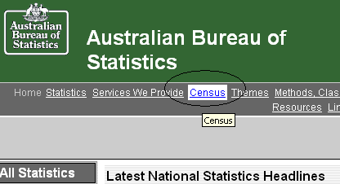

❷ The page which appears will present a range of types of census information, including QuickStats, tables and maps.
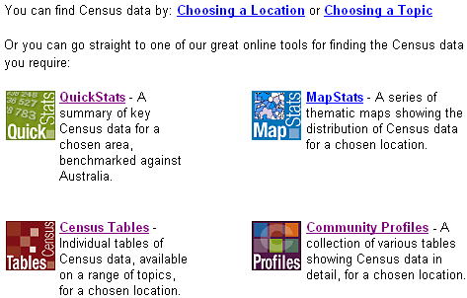

❸ Select ‘Quickstats’
In the next screen, click on ‘Search’
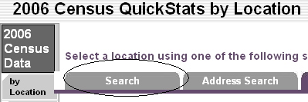

❹ Next you will be asked to type in the name of a city, town, suburb, postal area or electorate.
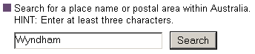

❹ After you chose an area, the computer will inform you of the range of places with this name. Select the locality of interest to you. In the example below, we chose the municipality of Wyndham, in Victoria.
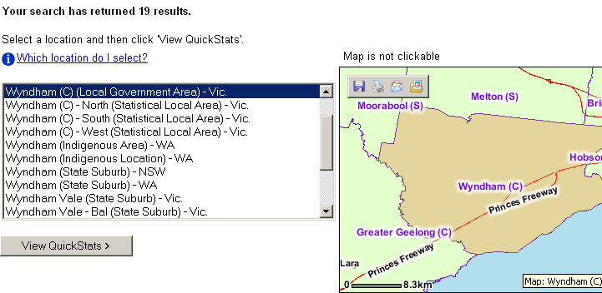

❺ A map of the area will appear to the right. To view statistics about the people and households in the locality you have chosen click the ‘View Quickstats’ button, on the lower page.

❻ The table of social statistics about your locality will appear, giving information about population, birthplaces, languages, families, housing, employment, occupations, and transport.

FOR SURVEY RESULTS AND OTHER INFORMATION….

❶ Click on the section marked ‘Access to all ABS products and services’ situated at the left-hand side of the screen.
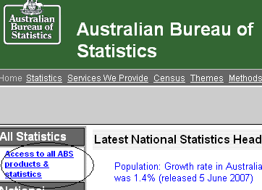

❷ The following screen will appear. To search by topic, click on ‘By Topic’, below.
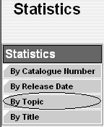

A range of topics are presented. Since we’re interested in social statistics, we’ll chose ‘Population/People’
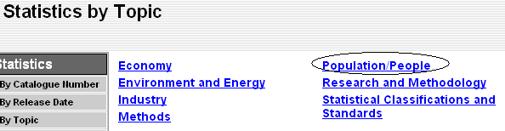

A further list of topic areas appears, all related to people and their circumstances

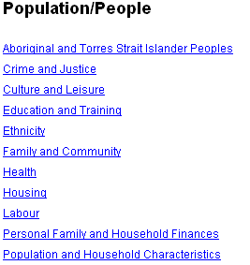
Finally, for further ABS inquiries, phone 1300 135 070 or email client.services@abs.gov.au
Major Sources of Social Statistics: III
The Department of Sustainability and Environment: Know Your Area
❶ Website: www.doi.vic.gov.au/doi/knowyour.nsf > Go to the section called ‘Know your area’\
This website presents population estimates, census information about social conditions, housing sales prices, and local residential developments, for Victorian municipalities and suburbs.
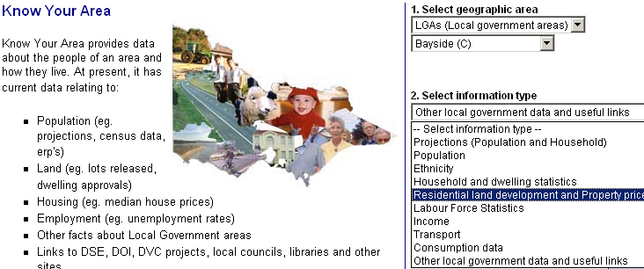

❷ Within the ‘Know Your Area’ page which appears, select the locality, then the type of information you wish to view. Follow the further prompts to select the information you require.

The Melbourne Atlas is in the Department of Sustainability and Environment website, at:
http://www.dse.vic.gov.au/DSE/dsenres.nsf/LinkView/9CA360582B427FBFCA2570AD007B7BC26EDCD66E75635AADCA2571BF00242532
Once in the Atlas home page, scroll down to the main topics and select a topic of interest.
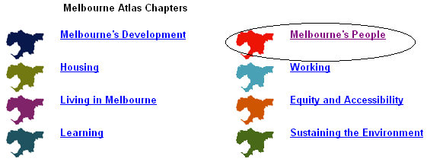
A list of relevant maps will appear. Click on one to select and view it in detail.
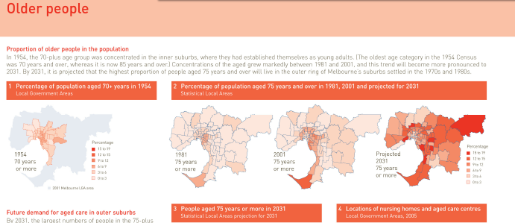
Major Sources of Social Statistics: IV
Community Indicators Victoria (CIV)
Website: www.communityindicators.net.au/
This site provides a range of measure of local conditions and perceptions, drawn from the Census, government departments, and the findings of a state-wide survey conducted by CIV.
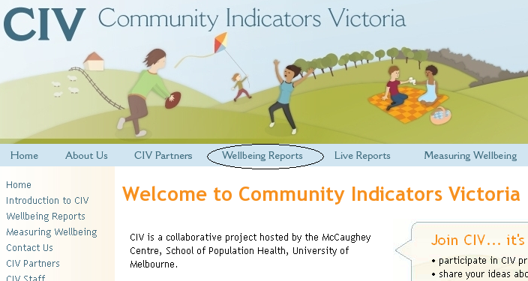
❶ Wellbeing Reports: Click on the heading ‘Wellbeing Reports’ (above),
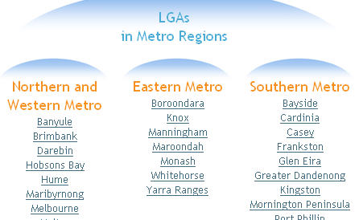
Click on the name of any of the Victorian municipalities which now appear on the screen, to view a summary of indicators of health and wellbeing for that area.
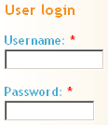
❷ Detailed Reports: First, click on ‘Become a member >>’ on the right hand side of the screen and follow the prompts, to obtain a username and password. Then login (at right)

Next, click on in the upper part of the screen, and follow the prompts
to select geographic areas………..and indicators for your report.
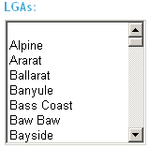
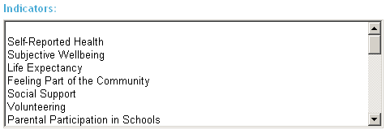
Listening and Talking
To learn more about circumstances which may not be easily measured or categorized, including subjective experiences, reasons for actions, or questions requiring thoughtful consideration, it may be necessary to stop counting and start listening.
Conversations may reveal details about personal circumstances, feelings and opinions, experiences and behaviour, whose variety and complexity far exceeds the scope of anything which may be counted and categorised.
Discussion also allows one to investigate a subject whose nature and scope is not clear, or when circumstances and experiences vary widely from person to person and therefore need to be explored in detail on an individual basis.
Moreover, talking to people has the further benefit of informing us of the reasons why people think, feel or behave as they do – which is often at least as important as knowing what they think and do.
Such discussions may be held with people about their own experiences, perceptions and circumstances, or with representatives of community agencies which may work directly with the people and circumstances of interest. This latter course is especially useful where the issues under consideration may be of a sensitive nature or where opportunities to speak with the people concerned are limited.

Even so, there are still some limits to the insight one can obtain though conversation.
- People may inaccurately recall events of the past, choose not reveal information of potential embarrassment or harm to themselves, or simply not know the answers to the questions asked of them.
- The time required to arrange, conduct and document interviews may be considerable; and so therefore, may be the cost.
- Since the time which a respondent must commit to lengthy, in-depth interviews is substantial, many people may decline to participate. As a result, those who do complete the survey may not form a random sample of the community. And so, as the level of detail sought about people’s personal circumstances and experiences increases, the ability to obtain a random and representative sample of a community declines.

The subject of interviews, focus groups and other types of conversation falls beyond the range of topics covered here. However, the information that people can provide about their own thoughts and experiences is a valuable supplement to statistical information, and forms an essential foundation to any understanding of the people and their communities.

From the findings of the 1996 Survey of Literacy and Numeracy, and the 2006 Census.

