Climate Change and Community Health and Wellbeing
H. Brown, 2021
THE CAUSES AND NATURE OF CLIMATE CHANGE
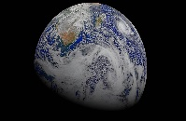
Natural Climate Change
The term ‘weather’ represents the particular conditions of the atmosphere at a specific time and region. ‘Climate’ on the other hand, is the long-term weather pattern (9, 10), with climate trends often recorded over decades or centuries (9). Even so, climate may be predicted when it is influenced by known and measurable conditions (4).
Climate change has occurred on many occasions during the 4.5-billion-year history of the Earth, due to natural conditions such as fluctuations in the intensity of the sun, alterations in the orbit of the Earth, meteorite impacts, the evolution of life (which added most of the oxygen to our atmosphere (91)), volcanoes, continental movements and others (4, 92).
One of the natural conditions which regulates climate is the effect of atmospheric gases which absorb heat. Unlike nitrogen and oxygen (which account for 99% of the atmosphere (59)), naturally occurring gases such as carbon dioxide, methane, nitrous oxide and water vapor absorb and trap some of the heat from the sun which would otherwise pass into space. This natural ‘greenhouse effect’ raises the temperature of the atmosphere by about 33 degrees, which prevents the planet from freezing and sustains conditions congenial to human life (34, 4).

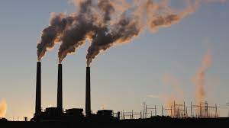
Climate Change due to Human Activity
However, the tempo of human activities, including the burning of coal, oil and gas, to power vehicles, generate electricity and support industry, has accelerated during the past 150 years, increasing the amount of carbon dioxide and other greenhouse gases emitted into the air. This has trapped further heat in the atmosphere, triggering rises in average, global temperatures, declines in the extent and depth of ice sheets, rising ocean temperatures and acidity, changes in weather patterns, and disruptions to natural environments such as forests and wilderness areas (4, 11, 10). The possibility of such events was foreseen in the nineteenth century by Swedish scientist Svante Arrhenius, who investigated the likely impacts of rising carbon dioxide levels upon the world's climate (47).

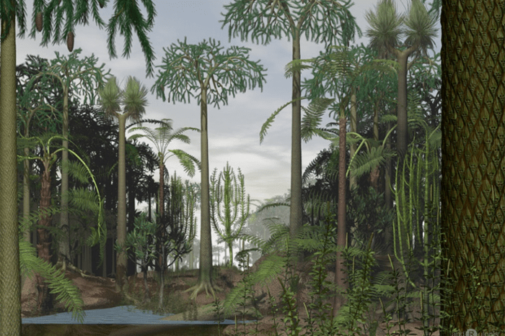
The Role of Fossil Fuels in Human-caused Climate Change
Coal, oil, gas, oil shales, bitumen and tar sands are termed 'fossil fuels', owing to their ancient, organic origin. These substances – which are largely made up of hydrogen and carbon – originated with photosynthesizing algae, bacteria and plants, which thrived in swampy, tropical forests and swamps 350 to 500 million years ago (15, 16, 17). After they died, these organisms formed deposits in the soil or sea floor, sank beneath the ground, and under rising pressure and temperature were gradually converted to coal, oil, gas and other hydrocarbons (85). Being lighter than rock, these fossil fuels remained close to the earth’s surface, forming a convenient source of energy for people millions of years later, enabling human civilization to “...harness the power of ancient suns.” (89)
Since ancient times, coal, oil and gas have been used for domestic heating, lighting, distilling water from brine and other purposes, and bitumen for patching up walls or roads (86) and for other structural or decorative purposes (94). The industrial revolution found further applications for fossil fuels, with the combustion of coal powering steam engines, generating electricity and supplying heat for buildings; oil refined to produce paraffin and kerosene for lamps; and gas used to light streets and homes (87).
Today, fossil fuels are widely used for heating, cooking, transport and industrial purposes as well as the manufacture of heating oil, waxes, lubricants, asphalt and food for animals (58, 57). They also form the primary energy source for human civilization, in 2019 accounting for 84% of word energy use, including 100% in Saudi Arabia and Singapore, 91% in Africa and Australia, 85% in China, 83% in the US, 74% in Europe and 21% in Iceland (97, 88, 97).
Combustion of fossil fuels, along with other industrial and agricultural activities, generates the greenhouse gases such as carbon dioxide, nitrous oxide and methane. Carbon dioxide though, exerts the major impact upon atmospheric warming and climate change, as it is the most abundant and is relatively enduring (34).
Finally, rising global temperatures themselves, generate further greenhouse gases, first, by causing the evaporation of water – itself a greenhouse gas, accounting for half of the influence of greenhouse gases upon global temperature – and second, by warming permafrost soils, inducing them to release methane, trapped beneath the surface, into the atmosphere (4).

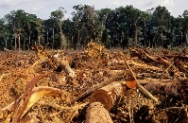
Deforestation and Climate Change
A further human activity which increases levels of greenhouse gases in the atmosphere and raises global average temperatures, is the clearing of forests. Trees and plants use the energy of the sun to absorb carbon dioxide from the air and combine it with water, to form the molecules they need for growth – a process called photosynthesis. In this way, plants effectively store carbon and restrain the rising atmospheric levels of carbon dioxide. However, when forests and wilderness are cleared or burnt, the carbon within these plants is returned to the atmosphere as carbon dioxide. Deforestation therefore reduces the absorption of carbon dioxide by plants, raising its level in the atmosphere (35, 36, 38).
An estimated 24 million hectares of trees were lost to the world in 2019 – an area larger than Victoria – and in the first two decades of this century a tenth of the worlds tree cover was destroyed, contributing over 112 gigatons of carbon dioxide emissions (39). In Australia, tree cover declined by 8.5 million hectares, or one-fifth of its total, during the same period (70).

Global Warming and Population Growth
Sustained and increasing combustion of fossil fuels, as well as clearing of natural habitat for farming and other human activity, is largely driven by population growth. The world’s population has risen 15-fold since the late 17th century (90) and is expected to surge by a further two billion, to 9.7 billion persons, by 2050. Among the highest growth forecasts are for the Congo, Egypt, Ethiopia, India, Indonesia, Nigeria, Pakistan and Tanzania (68) – nations already vulnerable to the impacts of climate change.
As one investigator explains: "...every week an extra 1.5 million people need food and somewhere to live. This amounts to a huge new city each week, somewhere, which destroys wildlife habitats and augments world fossil fuel consumption" (55).

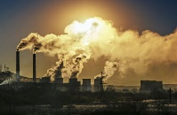
Greenhouse Gases and Further Rising Temperatures
Scientific researchers warn that, if the production of greenhouse gases is not suspended, global average temperatures will continue to rise, in the range of three to six degrees by the close of this century (4). As the Australian Academy of Science (2015) explains: "It is known that human activities since the industrial revolution have sharply increased greenhouse gas concentrations; these gases have a warming effect; warming has been observed; the calculated warming is comparable to the observed warming; and continued reliance on fossil fuels would lead to greater impacts in the future than if this were curtailed."
Moreover, since coal, oil and gas take millions of years to form within the earth, they cannot be replaced (18). One analyst forecast that oil, coal and gas reserves may become critically depleted within 35, 107 and 37 years respectively, leaving coal as the only commercially viable fossil fuel by the latter half of this century (19). If these predicted events transpire, then resources which were created over three hundred million years or more would have been largely exhausted in three centuries. Curtailing the use of fossil fuels would therefore not only help to slow the process of climate change but may also furnish civilization with an opportunity to refine and adopt techniques for generating energy by more dependable means.

Observed Changes to Climate
Investigators have recorded increasing atmospheric carbon dioxide levels, coupled with rising average global temperature and changes in climate such as alterations in rainfall patterns, rising intensity of storms, heatwaves and bushfires, warming and acidification of the oceans, rising sea levels, deterioration of terrestrial and aquatic habitat, and the endangerment or extinction of species (4, 9). These trends and developments form the subject of this section.

Rising Carbon Dioxide Levels and Average Temperatures
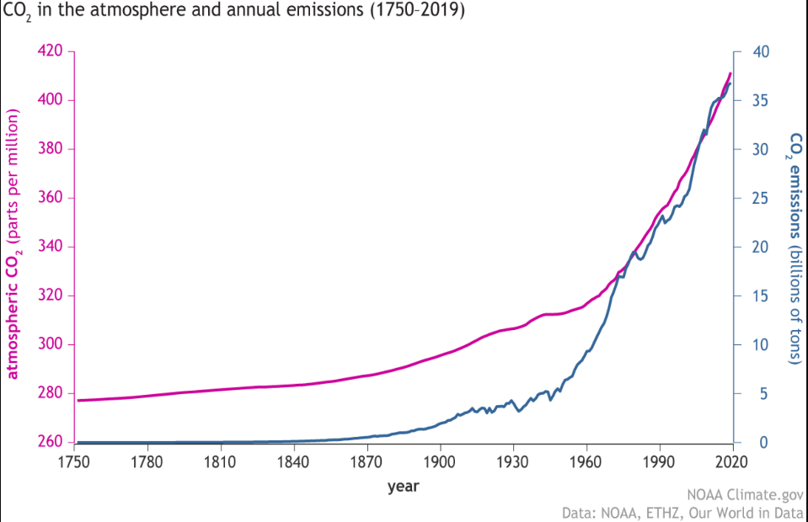
During the past two hundred years, accelerating industrial activity has been matched by rising fossil fuel consumption (4), raising atmospheric carbon dioxide from 280 parts per million to over 400 ppm at present (13) – a concentration unsurpassed in the preceding two million years (14). The accompanying diagram illustrates the match between emissions of carbon dioxide and its rising atmospheric concentration.

Carbon dioxide emissions and carbon dioxide atmospheric concentrations (34)

And with increasing carbon dioxide levels, the past century has seen rising average atmospheric and ocean temperatures, contraction of snow and ice fields, and the growing frequency and intensity of hot days, coupled with fewer cold ones. This association is no mere coincidence, since carbon dioxide is known to absorb and retain heat.
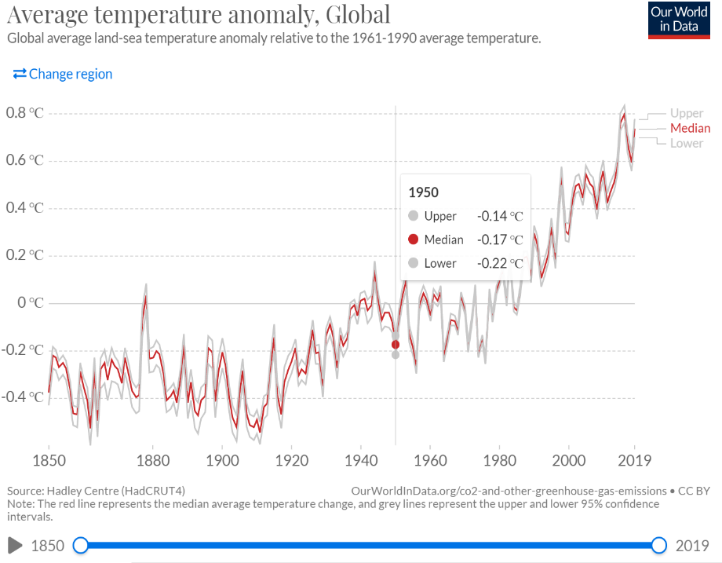
Average temperatures on earth have been rising during the past 150 years, and to date are believed to have risen by approximately one degree in that time (10, 9, 51). Much of this change has transpired in recent years, with each of the past few decades warmer than all previous decades since 1850 (4), and NASA reporting that the previous five years had been the warmest five years in centuries (10). The diagram at left depicts the rising average global temperature levels since the mid-nineteenth century.

Temperature average difference from 1961-1990 average temperature: 1750-2019 (31)

In Australia, average surface temperatures are reported to have risen by between 1 and 1.5 degrees since 1910 - when records were first kept (8, 11, 41), with the ten warmest years on record occurring since 2002 (4).
If international agreements to reduce greenhouse emissions are fulfilled, global average temperatures are still forecast to rise by a further three degrees (41, 48) – raising temperatures four degrees above their levels before the industrial revolution (4). By contrast, the CSIRO cautions that, if no action is taken to arrest global warming, average temperatures may rise a further 5.1 degrees by the close of the century (1).
Changes in average global temperatures of such a scale may trigger major climatic changes. The Australian Academy of Science informs us that the last ice age, 20,000 years ago, was just five degrees colder than today, yet the earth was largely engulfed in ice and the oceans were 100 meters lower than their present levels (41).
Moreover, current forecasts may underestimate future average global temperature rises, since evidence suggests that aerosol production (which tends to lower temperatures), volcanic activity and a decline in the intensity of the sun (92), may have temporarily constrained the pace of global warming, with the result that global average temperatures may surge when these conditions abate (4).

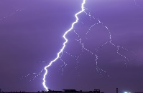
Extreme Weather Events
Climate change is expected to result in an increase in the intensity and frequency of extreme weather events, such as flooding, droughts, fires, heat waves, hurricanes and cyclones (2, 5, 41), with Australia among the regions of the world most vulnerable to such circumstances (3).
A rising frequency of fire-risk days due to rising temperatures and drying conditions is forecast in the southeast (4), coupled with declining rainfall and snow in western Australia and the southeast (2, 4), and an increase in droughts (3, 11).
Despite these developments, a rise in the number of heavy rainfall events is also expected in Australia and around the world. Climate change is also expected to aggravate the frequency and intensity of storms and floods (2, 10), including more floods and heavy downpours forecast in Victoria (4, 11). Such flooding is not expected to improve water supply though, except in basins with dams that can store excess water for later use (3).
Further observed trends include rapid melting of ice, resulting in a decline in glaciers and the ice sheets of the Antarctic and Greenland (10, 4). As melting ice sheets discharge water into the sea, and sea water expands due to rising ocean temperatures, sea levels are rising at about 3 mm. per year (51) – exposing coastal and island communities to the risk of flooding (10, 4, 5, 11). Notably, rising sea levels are likely to persist for centuries, regardless of any remedial action taken to arrest climate change in the meantime (4).

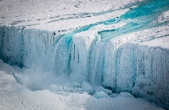
The Risk of 'Tipping Points' Placing Climate Change beyond the Control of Human Civilization
Investigators warn of 'tipping points', where continued warming of the earth’s atmosphere or oceans may trigger uncontrollable acceleration of climate change events. Possible tipping points include dying-off of the Amazonian forests, irreversible melting of the Greenland ice sheet, alteration of ocean currents by increased rainfall or ice melt, or a change in the monsoon rainfall in west Africa – any of which may abruptly quicken the pace of climate change, causing further global disturbances.
Scientists warn that incidents might be set off by average temperature rises of as little as one or two degrees (41, 45, 46, 48) – well within the scope of most forecasts.

IMPACTS OF CLIMATE CHANGE
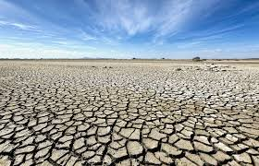
Agricultural Disruption
Rising temperatures, declining rainfall, drying of the land, droughts and floods, all may contribute to the disruption of agriculture and reduced access to food.
Rising temperatures and declining rainfall throughout the world are expected to increase in the frequency and duration of droughts (7, 10) further reducing water available for irrigation of crops and the productivity of livestock (2). Looking to Australian conditions, some forecasts point to a possible rise in average temperatures of four degrees in southeastern regions such as Victoria and Melbourne during the next fifty years, with a doubling in the days over 35 degrees, and dwindling rainfall – all contributing to droughts and a decline in water for agriculture, industry and human consumption (8).
Reduced rainfall resulting from climate change may also diminish river flows and water available for agriculture, resulting in a decline in agricultural production. As one commentary forecasts, declining water will “…transform pastures to dust, destroy crops and kill livestock” (2). Meantime, water shortages may be compounded by rising demand from a burgeoning population, increased demand for meat by growing affluence, and a demand for water by growing gas extraction and biofuel production industries (21).
Further risks to agriculture associated with global warming include the disruption of pollination of plants by insects and other animals – an interaction which supports 9.5% of global agricultural output (78) and a development which jeopardizes up to $577 billion in crop output (51). Another is the introduction of new pests to the environment (80), with researchers warning that many farming countries will be “…fully saturated with pests by the middle of the century.” (81).
The impacts of climate change upon agriculture may be accentuated by the loss of farming land. Nearly one third of the worlds arable land lost in the past 40 years due to poor conservation practices, and soil is now being depleted between 10 and 100 times faster than it is forming (20).

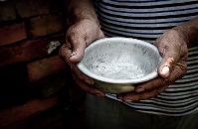
Impact on Food Production
Rising temperatures are expected to deplete Australian crops of cabbage, chickens, dairy, lemons and others (8), with predictions that a temperature rise of three degrees may diminish crop yields of wheat by 18%, and fruit and vegetables by 14%, owing to elevated temperature, reduced water for irrigation of crops, the impact of drought, harm to livestock due to heat stress, and erosion of grazing land by heavy rainfalls and floods (41). Such agricultural setbacks may raise the price of food, aggravating hardship for more disadvantaged segments of the community (66, 67) – such as people on low incomes, those without paid employment, and indigenous Australians, among whom a high prevalence of food insecurity is already well-documented in Australia (60, 61, 62, 63, 64, 65).
For rural communities, such declines in agricultural production may jeopardize their prosperity and wellbeing, displacing many of their residents from the land (3).

Malnutrition and Conflict
Droughts have already afflicted over one billion people in the past decade, with the World bank reporting that the 2017 drought caused the loss of agricultural produce sufficient to feed over 80 million people for the previous seven years (2). Malnutrition affected 11% of the world’s population in the same year, including people in nearly all nations of sub-Saharan Africa and South America (2), with consequences that presently include stunted growth among 59 million children in Africa (82).
The United Nations reports that drying and degradation of the land, dwindling access to water and rising sea levels, resulting from climate change, are worsening world hunger (95). And the growing impacts of climate change on food production are expected to worsen food shortages in poorer nations and communities (2, 4, 3), prompting forecasts that by 2030, 100 million people may be plunged into poverty by climate change (40).
Many expert observers caution that the resulting hunger, and competition for diminishing land and water resources, may ignite regional conflicts, displacing large numbers of people and precipitating refugee crises throughout the world (3, 4, 2).

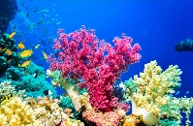
Destruction of Marine Life
Global warming is raising the temperature and acidity of the sea, with adverse impacts upon ocean life and commercial fishing areas.
Rising ocean temperatures are already inducing some marine species to move to cooler waters 'outside their normal range' (3), jeopardizing marine ecosystems and disrupting the fishing industry.
Meantime, as carbon dioxide accumulates in the atmosphere, about a third (79) dissolves into the sea water, forming carbonic acid. This process has raised the acidity of the oceans by 30% to date (34), impairing the formation of shells and skeletons by marine organisms and depleting the biodiversity in many ocean regions, including the Great Barrier Reef (3). Moreover, it is postulated that such acidification of oceans, once well underway, may take thousands of years to be reversed (41).
Rising Sea Levels and Coastal Flooding
As global average temperatures rise, ice resting upon Antarctica and Greenland is expected to continue to melt and drain into the sea, thereby raising ocean levels. Until the nineteenth century, sea levels rose a few centimeters each century – a rate which has soared to 3 centimeters per decade, in the past twenty years (51).
It is forecast that sea levels may rise by up to two meters by the close of this century if the rate of carbon dioxide emissions does not abate, exposing an estimated 650 million people in coastal cities and communities to the risk of annual flooding (73). Coastal cities in China, India, Indonesia, Burma, Thailand, Japan, Vietnam, Nigeria and Cote D’Ivoire are among those at immanent risk (74). For example, a study by the Work Bank and Asian Development Bank concluded that 26% of the population of Ho Chi Minh City was affected by extreme storm events, and that this figure may rise to 60% by 2050 (3).
In addition, island nations such as Tonga, Fiji, Samoa, Tuvalu, Kiribati and others face an increasing threat to natural habitats, infrastructure, water supplies and farming, stemming from climate change (75, 76).
Rising sea levels and storm surges are also a growing threat to coastal areas in Australia (3,4), with the Australian Academy of Science (2021) observing that historical 1-in-100-year coastal flooding events are likely to occur annually by 2100, jeopardizing people and infrastructure in many communities (41). Notably, more than 85% of Australia’s population lives along the coast, and an estimated $226 billion in commercial, industrial, road, rail and residential assets would be placed at risk of flooding in the event of a 1.1 m sea level rise by 2100 (41).

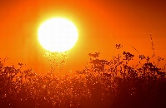
Heatwaves
Rising average global temperatures have been accompanied by an increase in the number and intensity of hot days and fewer periods of extreme cold (10, 3, 4). In Australia, the number of record hot days has doubled since 1960, with heatwaves more enduring and intense than in the past (1). And with a predicted rise in average temperatures of three degrees by the close of this century, it is forecast that the probability of a heatwave occurring in a particular year will soar from 1.7% in 2010, to 79% in future, while the number of days where the temperature exceeds 35 degrees may treble in many Australian cities and towns (41).
Notably, heatwaves are often amplified in urban areas, where dark surfaces and buildings retain heat and hot air, raising the temperature by 1-3 degrees and elevating evening temperatures by up to 12 degrees (1). With increasing global urbanization, a rising proportion of the Australian population is likely to be exposed to the risk of further elevated temperatures (1).
Heatwaves increase the incidence of cardiovascular illness, renal disease, heat stroke, mental confusion and other conditions. A heatwave recorded in southeast Australia in 2009, which raised temperatures in parts of Victoria to 49 degrees (83), was accompanied by a 25% rise in ambulance emergency cases and 2.8 fold rise in cardiac arrest callouts; doubling in calls to GPs to attend a deceased person; a 12% rise in number of emergency department attendances and tripling in number of patients dead on arrival; and an overall increase of 62% in deaths (6). Elsewhere in the world, heatwaves have been accompanied by high levels of mortality, including 70,000 deaths in Europe in 2003 and 55,000 in Russia in 2010 (1).
Those most vulnerable to heatwaves include older or disabled people, due to their lesser physical resilience and often limited mobility; children, owing to their developing respiratory and neurological systems, limited capacity to control their internal temperature, and reliance upon caregivers to keep them at a safe temperature; people in lower socioeconomic circumstances, due in part to lack of air conditioning and poor home insultation (97); people with pre-existing illnesses such as heart, lung or kidney disease; and indigenous people in remote communities (1, 3, 6, 41). Outdoor workers too, may be at risk, especially if they are required to keep pace with machines or are paid by output (1).
An expected doubling in the percentage of Australians who are aged 65 years or more, from 13% in 2007 to approximately 25% by 2056 (1, 44), may heighten the susceptibility of the population to heat stress.
The Australian Academy of Science (2015) however, concedes that while the threat of an increasing frequency and intensity of heatwaves is an immanent prospect, in southern Australian regions "…there is likely to be an offsetting reduction in the number of cold-season deaths." (4) – with cold weather currently accounting for 6.5% of mortality in Australia (97).
Energy demand is forecast to double and even quadruple in some northern cities with a 3-degree temperature rise predicted by 2011, due to increased use of air conditioning (41). As a result, heatwaves may place a strain on ageing power generation plants (85) owing to steep rises in electricity usage to power air conditioning while also inflicting damage upon transport and other infrastructure (1, 4).

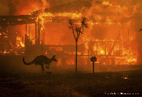
Bushfires
Dwindling rainfall in southern Australia, coupled with rising temperatures, intense heatwaves, and more frequent droughts is expected to raise the likelihood of bushfires (3, 1, 7, 41), particularly in western Victoria and Gippsland, and in the urban periphery which increasingly encroaches upon bushland (7). The impact of bushfires is illustrated by the destruction inflicted by the 2019/20 fires, which killed or displaced three billion land animals, caused $10 billion in damage, burned over ten million hectares - including 80% of the Blue Mountains World Heritage Area - and whose smoke affected 11 million Australians (41, 96).
Though Victoria accounts for just three percent of the land area of Australia, historically it has endured approximately half of the losses from the nation’s bushfires and two-thirds of the accompanying fatalities (7). Climate change may aggravate this trend. The number of extreme fire risk days has grown in the past four years in Australia (4), and in Victoria, longer fire seasons and 60% more fire risk days are forecast for the near future (11) with the annual average $180 million cost of bushfires in Victoria expected to double to nearly $400 million by the mid-century (7).
In addition, heatwaves, bushfires and dust from droughts, are also expected to reduce air quality, aggravating respiratory and cardiovascular problems, especially in vulnerable individuals such as older people, very young children and those rendered susceptible by pre-existing illnesses (3, 7, 41).

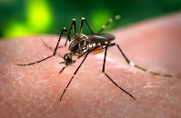
Spread of Tropical Diseases
Climate change is altering the geographic distribution of tropical diseases, as they shift south under warming climatic conditions (3). It is forecast that rising global average temperatures may be accompanied by an increase in the incidence of Ross River virus, dengue fever, Zika and Lyme disease, in more southerly regions of Australia (41, 72).
Indeed, evidence suggests that the Ross River virus – the most common mosquito-borne disease in Australia, which infects 2,000 to 9,000 people each year, often causing chronic, debilitating joint pain – may already be moving from tropical northern Australia where it is endemic, to southern Australia, under the impetus of rising atmospheric temperatures (42, 71).

Destruction of Natural Habitats and Wildlife
Dwindling natural habitats – as a consequence of increased temperatures, reduced rainfall, droughts, fires and other climate change impacts, coupled with deforestation and other land clearing (29) – threaten many species with extinction (10, 9), a prospect which would become more acute as average global temperatures rise in the future.
A recent inquiry engaged over 450 investigators and reviewed 15,000 papers, concluding that approximately one million species face the possibility of extinction world-wide, including a one-third of marine mammals and two-fifths of amphibians, due in part to the impacts of climate change. Its report added that three-quarters of the natural environment on land and two-thirds of the marine environment have already been altered by human activity, warning that "Biodiversity ...is declining faster than at any time in human history." (51). It is reported that the risks of habitat destruction and resulting extinction are most acute in South America, New Zealand and Australia (26, 54) – a country which accounts for half of all the world’s mammalian extinctions in the past 200 years (41). By 2014, the Bramble Cay, an Australian native marsupial, had become extinct due to the impact of a storm surge upon its limited coastal habitat – an effect attributed in part to climate change (28) and one which foreshadows further extinctions as global average temperatures continue to rise.
Moreover, one commentator adds that: "Even species not threatened directly by extinction could experience substantial changes in abundances, distributions, and species interactions, which in turn could affect ecosystems and their services to humans." (29). Rising temperatures are pushing many species toward the poles – that is, southward in Australia – as they shift from regions of rising temperature in favor of cooler environments (4, 79). For example, a recent inquiry into the geographic distribution of 49,000 aquatic species showed that many tropical fish are moving south to escape rising ocean temperatures (77). However, southward movement in response to rising temperatures in Australia may not be feasible for many terrestrial species, due to its dry and flat interior, and often sparse plant life, and more challenging still for those which live on islands – conditions which may precipitate further extinctions (41).
Meantime, rising water temperatures and increased acidification of the ocean has contributed to severe bleaching of the Great Barrier Reef and others, as acidic water drives out algae which live within corals (52). Bleaching also exposes coral to the risk of death (52) and harm other marine life (3). In 2016/17, a rise in ocean temperatures were accompanied by the most extensive bleaching of the reef ever recorded (54).
In addition to its impact upon animals and plants, destruction of natural environments harms the earth’s human inhabitants. As one commentator explains, nature bestows ”…inspiration, and learning, physical and psychological experiences…that are central to quality of life and cultural integrity” (51).

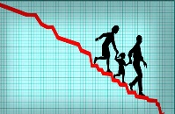
Economic Decline
Climate changes may exact a substantial economic toll upon civilization. This includes the rising cost of maintaining existing power generation infrastructure in conditions of rising demand; dwindling water supplies; increased costs of food; growing utility, water, and petrol costs; costly damage to coastal infrastructure due to rising sea levels and storm surges; the impact of droughts, storms and other more frequent intense weather events upon agriculture and infrastructure; and the expense entailed in mobilizing health and community services to address the impact of fires, storms, heatwaves and other climate-induced emergencies.
In Australia, a downturn in the $64 billion p.a. (2021 dollars) (56) tourism industry is a further economic risk, as temperatures increase, sea levels rise and damage to reefs and popular wildlife sanctuaries progresses. Coral reef bleaching and death threatens tourism at the Great Barrier Reef, annually worth an estimated $6.4 billion to the Australian economy, and a direct source of 39,000 jobs (53). Meantime, tourism at Uluru and Kakadu National Parks, and other popular tourist destinations in northern Australia, is imperiled by extreme heat and water scarcity; Australian beaches by rising sea levels and coastal flooding – which in Melbourne is projected to become 100 times more frequent; and ski tourism by dwindling snowfall (54).
‘* * * *
As carbon dioxide and other greenhouse gases accumulate in the atmosphere, they fuel a continued rise in average global temperature, resulting in worsening storms, floods and droughts, changes in rainfall patterns, heatwaves and wildfires, rising sea levels and coastal flooding.
Coupled with the impact of land clearing to feed a burgeoning world population, these events pose a growing risk to housing and infrastructure, coastal communities, food supply, the natural environment, and to the health, wellbeing and peace of vulnerable communities throughout the world.

BIBLIOGRAPHY
1. Hughes, L., Hanna, E. and Fenwick, J. (2016). The Silent Killer: climate change and the health impacts of extreme heat. Climate Council of Australia.
2. Mercy Corps (2019). How Climate Change Affects People Living in Poverty. Mercy Corps.
3. US Environment Protection Authority (2017). International Climate Impacts.
4. Australian Academy of Science (2015). The Science of Climate Change: questions and answers.
5. Dept. Agriculture, Water and the Environment (undated). Understanding Climate Change. Australian Government
6. Dept. Human Services (2009). January 2009 Heatwaves in Victoria: An Assessment of Health Impacts. Victorian Government.
7. Hughes, L. and Alexander, D. (2017). Climate Change and the Victoria Bushfire Threat. Climate Council of Australia.
8. Melbourne Sustainable Society Institute (2015). Appetite for Change: Global Warming Impacts on Food and Framing Regions in Australia. Melb. Uni.
9. Watson, J. (2016). Bring Climate Change Back from the Future. Nature. Vol. 534, No. 7608. 21 June 2016
10. NASA (undated). What is Climate Change? National Aeronautics and Space Administration.
11. Department of Environment, Land, Water and Planning (2020). Victoria’s Climate Science Report 2019, Dept. Environment, Land, Water and Planning.
12. Sun, C., Hurley, J., Amati, M., Arundel, J., Saunders, A., Boruff, B. and Caccetta P. (2019) Urban Vegetation, Urban Heat Islands and Heat Vulnerability Assessment in Melbourne, 2018. Clean Air and Urban Landscapes Hub, Melbourne, Australia.
13. Global Carbon Project (2018). Carbon budget and trends 2018.
14. Bureau of Meteorology and CSIRO (2018). State of the Climate 2018.
15. Outreach research (undated). The origin of life: The conditions that sparked life on Earth.
16. Maruyama, S, Ebisuzaki, T and Kurokawa, K. (2018). Origin and evolution of Earth and Life: Towards the establishment of astrobiology from Universe to genome. Proceedings of Science.
17. National Geographic (2020). Fossil Fuels.
18. National Geographic (undated). Non-renewable Resources.
19. Shafiee, S. and Topal, E. (2009). When will Fossil Fuels be Depleted? Energy Policy, Vol. 37, No. 1. pp. 181-189.
20. Tilman, D. (1999). Global environmental impacts of agricultural expansion: The need for sustainable and efficient practices. Proceedings of the National Academy of Sciences of the United States of America. May 25, 1999 96 (11)
21. UN Water (undated). Food, Water and Energy. United Nations, Geneva.
22. Berwald, S. (2019). One overlooked way to fight climate change? Dispose of old CFCs. National Geographic
23. Wilkins, J. (undated). Chlorofluorocarbons. Global Monitoring Laboratory
24. Environmental and Energy Study Institute (undated). Fossil Fuels.
25. National Geographic. (2020). Coal.
26. Urban, M. (2015). Accelerating Extinction from Climate Change. Science. American Association for the Advancement of Science.
27. Dept. Agriculture, Water and the Environment (2004). Threatened species and ecological communities in Australia. Australian Government
28. Purtil, J. (2019). An Australian rodent has become the first climate change mammal extinction. ABC 20 Feb. 2019
29. Neldner, V.J., Laidlaw, M.J., McDonald, K.R., Mathieson, M.T., Melzer, R.I., Seaton, R., McDonald, W.J. F., Hobson, R. and Limpus, C.J. (2017). Scientific review of the impacts of land clearing on threatened species in Queensland. Queensland Government, Brisbane
30. International Energy Agency (2018). Data and Statistics: CO2 emissions by energy source, World 1990-2017.
31. Ritchie, H. and Roser, M. (2020). CO₂ and Greenhouse Gas Emissions: CO₂ Emissions by Fuel. Our World in Data. OurWorldInData.org.
32. Bautista, H. and Rahman, K. (2016). Effects of crude oil pollution in the tropical rainforest biodiversity of Ecuadorian Amazon Region. Journal of Biodiversity and Environmental Sciences Vol. 8, No. 2
33. EPA Enforcement Alert. (2000). Frequent, Routine Flaring May Cause Excessive, Uncontrolled Sulfur Dioxide Releases EPA Alert Vol. 3, No. 9
34. Lindsay, R. (2020). Climate Change: Atmospheric Carbon Dioxide. Climate.Gov
35. Harris, N., Brown, S., Hagen, S., Saatchi, S., Petrova, S., Salas, W., Hansen, M.C., Potapov, P.V. and Lotsch, A. (2012). Baseline Map of Carbon Emissions from Deforestation in Regions. Science, Vol. 336, Issue 6088, pp. 1573-1576
36. Baccini, A., Goetz, S. J., Walker, W. S., Laporte, N. T., Sun, M., Sulla-Menashe, D., Hackler, J., Beck, P. S. A., Dubayah, R., Friedl, M. A., Samanta, S. and Houghton, R. A. (2012). Estimated Carbon Dioxide Emissions from Deforestation Improved by Carbon-density Maps. Nature Clim Change. Vol. 2, pp. 182–185
37. Cramer, W., Bondeau, A., Schaphoff, S., Lucht, W., Smith, B. and Sitch, S. (2004). Tropical forests and the global carbon cycle: impacts of atmospheric carbon dioxide, climate change and rate of deforestation. Phil. Trans. R. Soc. Lond. B (2004) Vol. 359, pp. 331–343.
38. Dean, A. (2019). Deforestation and Climate Change. Climate Council.
39. Global Forest Watch. (undated). Global Primary Forest Loss.
40. Khoday, K. and Ali, W. (2018). Climate Change and the Rise of Poverty. UNDP.
41. Australian Academy of Science (2021). The Risks to Australia of a 3-degree warmer world.
42. Shocket, M. S., Ryan, S. J. and Mordecai, E. A. (2018). Temperature explains broad patterns of Ross River virus transmission. eLife, 7, e37762.
43. Victorian Government (2018). Victoria in Future.
44. Australian Bureau of Statistics (2008). Population Projections, Australia, 2006 to 2101. Commonwealth Government, Canberra.
45. McSweeny, R. (2020). Tipping Points.
46. Lenton, T. (2011). Early warning of climate tipping points. Nature Clim Change 1, 201–209 (2011).
47. NASA (2000). Svante Arrhenius. National Aeronautics and Space Administration, Earth Observatory
48. Lenton, T.M., Rockström, J., Gaffney, O., Rahmstorf, S., Richardson, K., Steffen, W. and Schellnhuber, H.J. (2019). Climate tipping points — too risky to bet against. Nature. 27 November 2019.
49. Great Barrier Marine Park Authority (2020). Statement: coral bleaching on the Great Barrier Reef 26/03/20.
50. United States Environmental Protection Agency (undated). Greenhouse Gas Emissions. United States government
51. IPBES (2019): Global assessment report on biodiversity and ecosystem services of the Intergovernmental Science-Policy Platform on Biodiversity and Ecosystem Services. E. S. Brondizio, J. Settele, S. Díaz, and H. T. Ngo (editors). IPBES secretariat, Bonn, Germany.
52. National Ocean Service (undated). What is coral bleaching?
53. Deloitte Access Economics (2020). At what price? The economic, social and icon value of the Great Barrier Reef. Great Barrier Reef Foundation.
54. Hughes, L., Stock, P., Brailsford, L. and Alexander, D. (2018). Icons at Risk: Climate Change Threatening Australian Tourism. Climate Council.
55. Guillebaud, J. and Hayes P. (2008). Population growth and climate change British Medical Journal. 2008;337:a576
56. Tourism Australia (2020). The Economic Importance of Tourism to Australia.
57. American Public Gas Association (undated). A Brief History of Gas.
58. Evans, M. and Ramani, R.V. (undated). Coal Mining. Britannica.
59. Lunine, J (undated). The Atmosphere of Earth. Britannica.
60. Victorian Department of Health and Human Services (2014). Food Insecurity with Hunger, by Income and by Housing Tenure Type. Tabulation from data presented in ‘Challenges to healthy eating: findings from the Victorian Population Health Survey 2014’. Victorian Government, Melbourne.
61. Australian Institute of Family Studies (2018). Fairfield Refugee Nutrition project. Australian Institute of Family Studies, Canberra
62. Ramsey, R., Giskes, K., Turrell, G. and Gallegos, D. (2012). Food insecurity among Adults Residing in Disadvantaged Urban Areas: potential health and dietary consequences. Public Health Nutr 2012; Vol 15, pp. 227-237
63. Burns, C. (2004). A Review of the Literature Describing the Link between Poverty, Food Insecurity and Obesity with Specific Reference to Australia. VicHealth
64. VicHealth (2015). VicHealth Indicators Survey 2015. VicHealth, Melbourne.
65. McCrindle Consulting (2018). Food Bank Hunger Report 2018. Food Bank.
66. Beaudry, E. and McKay, F. (2020). How are Victorian Local Governments' responding to climate change and food insecurity? Health Promotion Journal of Australia. Vol. 32, No. 1.
67. Dixon, J., Donati, K.J., Pike, L.L. and Hattersley, L. (2009). Functional foods and urban agriculture: two responses to climate change-related food insecurity. NSW Public Health Bulletin. Vol. 20(2), pp. 14-18.
68. United Nations Department of Economic and Social Affairs (2019). World Population Prospects 2019: Highlights. United Nations, Geneva.
69. CIA (2020). CIA World Factbook. Government of the United States of America.
70. Global Forest Watch (2021). Australia Tree Cover.
71. Tong, S., Donald, K. and McMichael, A. J. (2001). Climate variability and Ross River virus transmission. Journal of Epidemiology and Public Health. Vol. 56, No. 8.
72. Paz, S. (2015). Climate change impacts on West Nile virus transmission in a global context. Philos Trans R Soc Lond B Biol Sci. 2015 Apr 5; 370.
73. Kulp, S. and Strauss, B.H. (2019). New elevation data triple estimates of global vulnerability to sea-level rise and coastal flooding. Nature Communications. Volume 10.
74. Nicholls, R.J., Hanson, S., Herweijer, C., Patmore, N., Hallegatte, S., Corfee-Morlot, J., Jean Chateau, K. and Muir-Wood, R. (2007). Ranking of the World’s Cities Most Exposed to Coastal Flooding Today and in the Future. Meteo France and Tyndall Centre for Climate Change Research.
75. Mimura, N. (1999). Vulnerability of island countries in the South Pacific to sea level rise and climate change. Climate Change. Vol. 12, pp. 137–143.
76. Pacific Coastal and Marine Science Center (2020. The Impact of Sea-Level Rise and Climate Change on Pacific Ocean Atolls. US Geological Survey.
77. Chaudary, C., Richardson., A.J., Scoeman., D.S. and Costello, M.J (2021). Global warming is causing a more pronounced dip in species richness around the equator. Proceedings of the National Academy of Sciences of the United States of America. Vol. 118, No. 15.
78. Gerard, M., Vanderplanck, M, Wood, T. and Michez, D. (2020). Global warming and plant–pollinator mismatches. Emerg Top Life Sci. 2020 Jul 2; Vol. 4, No. 1, pp. 77–86.
79. IPCC (2014): Climate Change 2014: Synthesis Report. Contribution of Working Groups I, II and III to the Fifth Assessment Report of the Intergovernmental Panel on Climate Change. IPCC, Geneva, Switzerland.
80. Bebber, D.P., Ramotowski, M. and Gurr, S.J. (2013). Crop pests and pathogens move polewards in a warming world. Nature Climate Change. Vol. 1 2013.
81. Holmes, T. and Gurr, S.J. (2014). The Global Spread of Crop Pests and Pathogens. Global Ecology and Biogeography. Vol. 23, pp. 1398–1407.
82. World Health Organization: Regional Office for African (2017). WHO’s Africa Nutrition Report highlights an increase in malnutrition in Africa.
83. Australian Government Bureau of Meteorology (2009). The exceptional January-February 2009 heatwave in south-eastern Australia.
84. Stock, A. (2014). Australia’s Electricity Sector: Ageing, Inefficient and Unprepared. Climate Council.
85. Rafferty, J.P. (undated). Do Fossil Fuels Really Come from Fossils? Britannica.
86. Kool, T. (2020). The Complete History of Fossil Fuels. OilPrice.com
87. Wrigley, E.A. (2013). Energy and the English Industrial Revolution. Philosophical Transactions of the Royal Society.
88. Geoscience Australia (undated). Australia’s Energy Production, Consumption and Exports.
89. Andrews, T.G. (undated). Coal and the Industrial Revolution. National History Education Clearinghouse.
90. Kumar, K. (undated). Modernization. Brittanica.
91. Beillo, D. (undated). The Origin of Oxygen in the Earth’s Atmosphere. Scientific American.
92. NASA (2020). Global Climate Change – Vital Signs for the Planet: Graphic: Temperature versus Solar Activity.
93. Strenchicov, G.L. (2016). The Role of Volcanic Activity in Climate and Global Change. King Abdullah University of Science and Technology.
94. Connan, J. (1999). Use and trade of bitumen in antiquity and prehistory: molecular archaeology reveals secrets of past civilizations. Philos Trans R Soc Lond B Biol Sci. Vol. 354(1379), pp. 33–50.
95. United Nations Climate Change (2018). UN Warns of Climate Change is Driving world Hunger. United Nations.
96. CSIRO (2021). The 2019-20 bushfires: a CSIRO explainer. Commonwealth Government.
97. Clarkson, S. (2015). Australia’s Death Rate due to Cold Weather almost doubles that of Sweden due to Poor Building Quality. CSR

As the organisms from which they originated grew by photosynthesis, which uses the energy of the sun’s light to combine carbon dioxide and water into the molecules required for their growth and survival.

